



|  |
| --- |
| FIND HOUSE |
| Author:  1. Xuan Dong Thi Thanh - Student1272834 (Leader)  2. Lan Nguyen Binh Phuong - Student1273079  3. Dac Pham Danh – Student1269153  Instructor:  Mr. Phan Huu Tri  Date: 18th June 2022  Semester: 3 |
| June 2022 |

TABLE OF CONTENT

TABLE OF CONTENT 2

ABSTRACT 1

CHAPTER 1: OVERVIEW 2

1. INTRODUCTION 2

2. SITEMAP 2

3. OBJECTIVE 5

4. SOME MAIN INTERFACE 5

CHAPTER 2: E-PROJECT DESIGN 6

1. DATA-FLOW DIAGRAM 6

1.1. Defination 6

1.2. Elements of data-flow diagrams 6

2. DFD ANALYSIS: DESIGN MAIN FUNCTIONS OF SYSTEM 7

3. DATABASE STRUCTURE 13

CHAPTER 3: INTERFACE SNAPSHOT 14

1. HOMEPAGE 14

2. LOGIN 17

3. REGISTER 18

4. NEWS 19

5. NEWS DETAIL 20

6. CONTACT 23

7. VISITOR INFO 24

8. ADMINPAGE 24

CHAPTER 4: USER GUIDE 25

1. HOMEPAGE 25

1.1. Description 25

1.2. Design and operation 25

2. REGISTER 28

2.1. Description 28

2.2. Design and operation 28

3. LOGIN 30

3.1. Description 30

3.2. Design and operation 30

4. PROFILE INFO 32

4.1. Description 32

4.2. Design and operation 32

5. LOG OUT 38

5.1. Description 38

5.2. Design and operation 38

6. REVIEW NEWS 39

6.1. Description 39

6.2. Design and operation 39

7. CONTACT 41

7.1. Description 41

7.2. Design and operation 42

8. LIVE CHAT 43

8.1. Description 43

8.2. Design and operation 43

CHAPTER 5: SUPERADMIN GUIDE 46

1. ACCESS TO ADMIN SITE 46

1.1. Description 46

1.2. Design and operation 46

2. ACCOUNT MANAGEMENT 46

2.1. Description 46

2.2. Design and operation 46

3. NEWS MANAGEMENT 48

3.1. Description 48

3.2. Design and operation 48

4. PACKAGE MANAGEMENT 51

4.1. Description 51

4.2. Design and operation 51

5. CATEGORY 53

5.1. Description 53

5.2. Design and operation 53

6. ADDRESS 54

6.1. Description 54

6.2. Design and operation 54

7. INVOICE 54

7.1. Description 54

7.2. Design and operation 54

8. CHANGE PASSWORD 55

8.1. Description 55

8.2. Design and operation 55

9. LIVE CHAT 55

9.1. Description 55

9.2. Design and operation 55

CHAPTER 6: PRIVATESALE GUIDE 58

1. ACCESS TO PRIVATESALE SITE 58

1.1. Description 58

1.2. Design and operation 58

2. ACCOUNT INFO 58

2.1. Description 58

2.2. Design and operation 58

3. NEWS MANAGEMENT 59

3.1. Description 59

3.2. Design and operation 59

4. PAYMENT 61

4.1. Description 61

4.2. Design and operation 61

5. NOTIFICATION 63

5.1. Description 63

5.2. Design and operation 63

6. CHANGE PASSWORD 63

7. LIVE CHAT 63

CHAPTER 7: ADMINISTRATOR GUIDE 64

1. ACCESS TO ADMINISTRATOR SITE 64

2. ACCOUNT INFO 64

3. NEWS MANAGEMENT 64

3.1. Description 64

3.2. Design and operation 64

4. AGENT MANAGEMENT 66

4.1. Description 66

4.2. Design and operation 66

5. PAYMENT 67

6. NOTIFICATION 67

6.1. Description 67

6.2. Design and operation 67

7. CHANGE PASSWORD 68

8. LIVE CHAT 68

CHAPTER 8: AGENT GUIDE 69

1. ACCESS TO AGENT SITE 69

2. ACCOUNT INFO 69

3. NEWS MANAGEMENT 69

4. NOTIFICATION 69

5. CHANGE PASSWORD 69

6. LIVE CHAT 69

CHAPTER 9: DEVELOPER GUIDE 70

1. INSTALL SQL SERVER 70

2. INSTALL VISUAL STUDIO 70

3. INSTALL VISUAL STUDIO CODE 71

|  |  |  |
| --- | --- | --- |
| STUDENT | TASK ASSIGNMENT | DETAIL |
| Xuan Dong Thi Thanh - Student1272834 (Leader) | Category  Category of house  News type  News details  Admin(company account)  Agent | * Show, search and filter list news * Show news detail with description, image, map location, … report news from user * Build admin site: agent management, set advertising for post, report news from company account * Build package advertising * Build Paypal payment * Build live chat |
| Lan Nguyen Binh Phuong - Student1273079 | Home  Private sale  Visitor | * Show, search, filter list news * Search engine * News management. * Create news with check the relevance of the post content. * Edit profile |
| Dac Pham Danh – Student1269153 | Login & Register  Super admin | * Build login and register progress * Account management * Categories & Listings Management * Send e-mail |

**Task assignment:**

# colored rectanglecolored rectangleABSTRACT

Real estate is a rapidly growing field in the country and everyone needs to hunt for a good house/property.

Generally people visit the various agents/brokers in order to buy/sell properties or find tenant.

Nowadays, the life of everybody is very hectic, it really becomes difficult for people each time to visit an agent, specify the criteria or make him understand the requirements and find a suitable and comfortable choice much quicker. Day by day the situation is becoming worst and people are finding it difficult to locate good houses.

According to the 2020 National Association of Realtors Profile of Home Buyers and Sellers, 51% of buyers found the home they purchased on the internet. To put this in perspective, only 28% found the home they bought through their realtor, and 4% from a yard sign.

Real estate websites are attracting so many eyeballs every month because they are adding value for both buyers and sellers. Buyers can preview hundreds of homes within a few hours from the comfort of their couch. Home sellers win, too; their home’s features and pictures are viewed by hundreds of shoppers in the market to buy a new home.

Realtors Portal as an online platform is a solution through by a group of agents that will connect property owners and brokers to tenants and investors. The site should focus on all commercial and residential real property categories including office space, Shops, commercial land, industrial property, Houses, Apartments, Villas, and businesses for sale, rent, and lease. This also features a premier real estate directory for real estate agents, property dealers, builders, and potential buyers of property. Realtors portal helps to search property buy and sell the property and also find useful information & resources to help users take wise and an informed decision about real estate.

We have taken effort in this project. However, it would not have been possible without the kind supports and help of our instructor Mr.Phan Huu Tri. We would like to extend our sincere thanks to Mr. Phan Huu Tri. We would like to express our special gratitude Aptech Aprotrain for their guidance and constant supervision as well as for providing nessessary information regarding the project and also for their support in completing the project.



# CHAPTER 1: OVERVIEW

## INTRODUCTION

Find House is a website that allows you to post, and search for real estate for sale or rent built on Visual Studio, .Net / ASP, and Angular platforms.

The website contains a variety of information about many types of real estate in many locations. The website has a user-friendly interface, the information is divided into categories and type for easy searching. Website is a place that allows users to post news or search for information related to real estate in the area. The site also categorizes news by categories and locations. Find House allows users to sign up for an account as an agent or seller and purchase a package to post and manage the news.

For visitors, it is easy to search many types of desired demand properties based on categories and filters. For agents and private sales, there are tools that make it convenient for them to post, manage news as well as buy additional subscription packages.

## SITEMAP

The website includes five parts: Visitor Site, Super Administrator Site, Administrator Site, Agent Site anb Private sale Site.

* **Visitor**

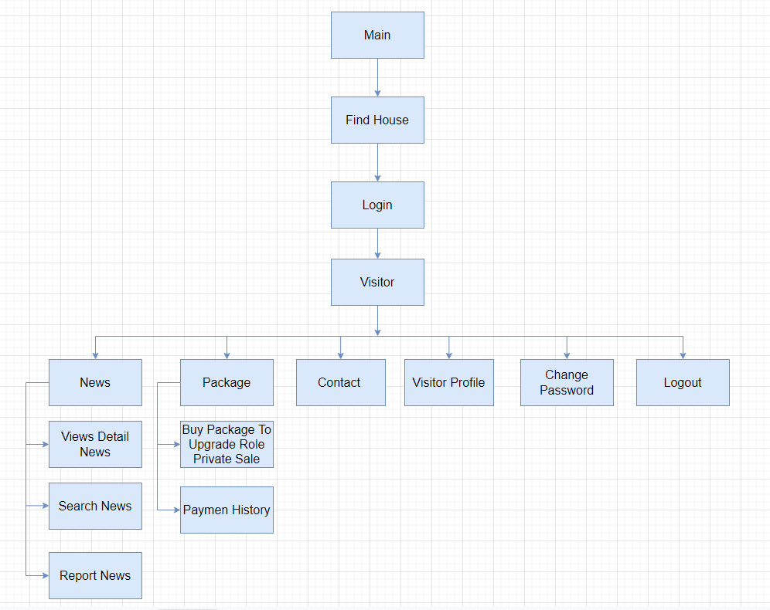

* **Super Administrator**

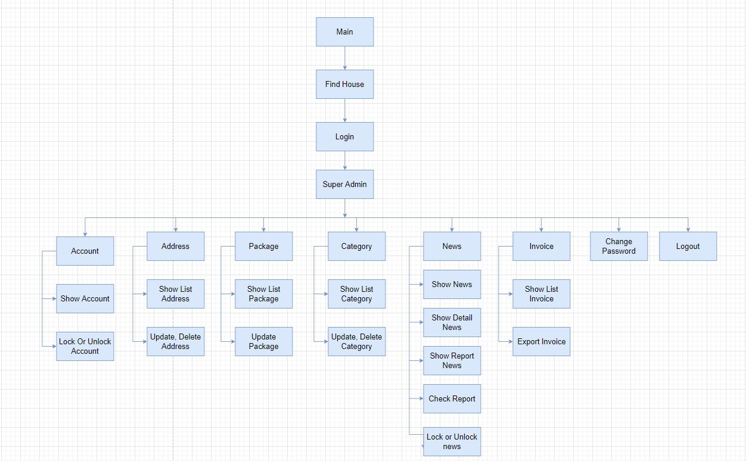

* **Administrator**

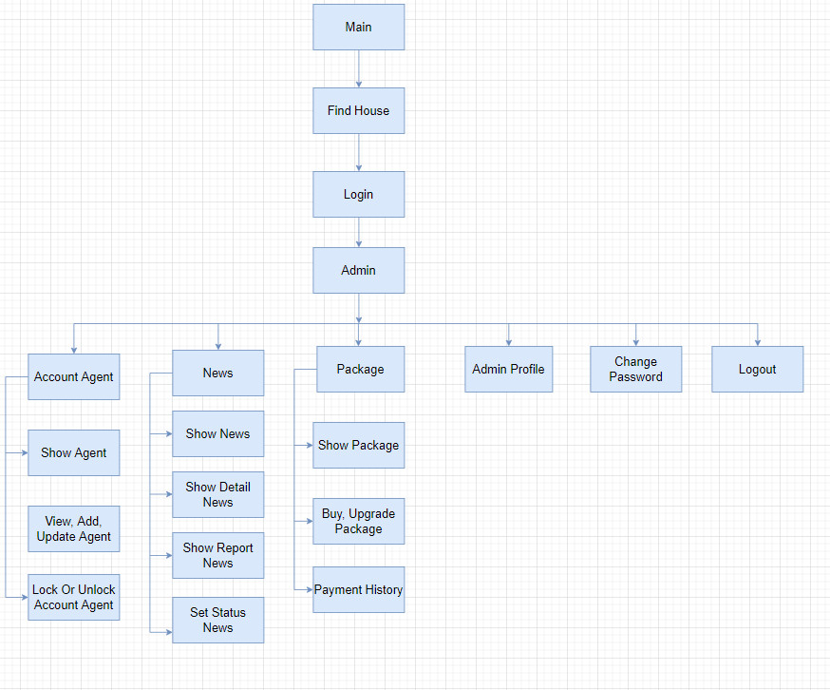

* **Agent**

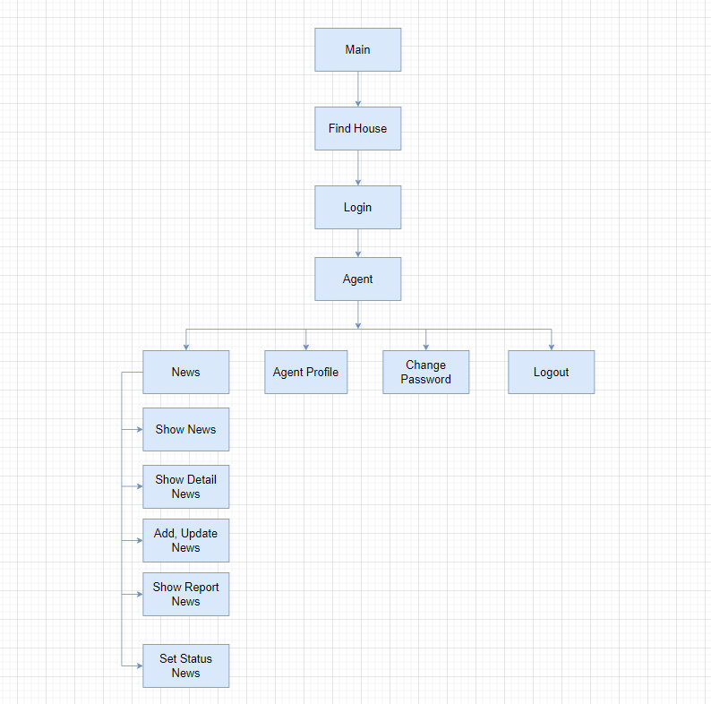

* **Private sale**

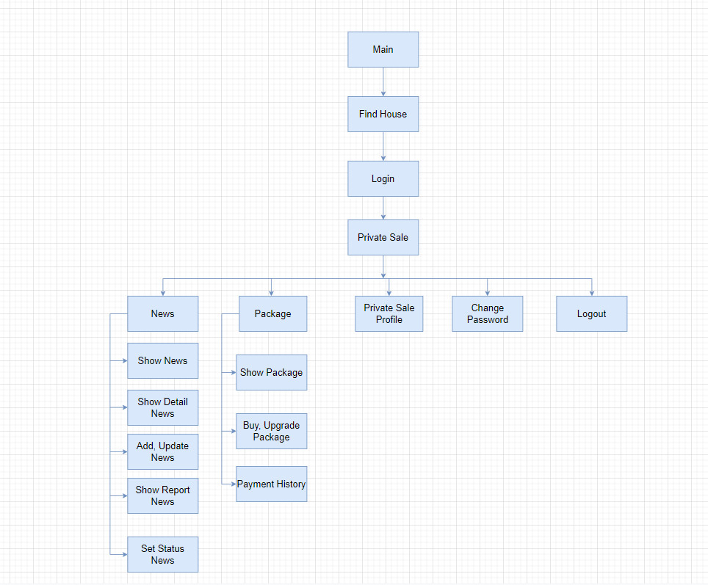

## OBJECTIVE

The main purpose is to build a website with information about real estate for sale and rent in the area. The interface needs to be friendly, with practical applications such as reasonable information management to make searching and filtering information easier, helping users to access information more easily. The management page also has the necessary features to effectively post and manage news, the website also has a paypal payment application when the manager wants to buy an additional limited post package. findhouse aims to help users access the information they want to find about the property, while also helping sellers make information about the property more known.

## SOME MAIN INTERFACE

* **Homepage**: Display information about real estate news classified by news type based on news purchased by advertising packages. The home page also has a search engine, and categories on the navbar to help users easily find information.
* **Newstype**: Display news based on the type of news purchased based on the subscription package.
* **Category of house**: Display news based on real estate type such as apartment, house, shophouse, villa, ...
* **Contact**: Show information about location, contact number, e-mail and customers can send  
  feedback to the Find House’s mailbox.
* **Adminpage:** Manage information about postings, categories, accounts, receive report information,…

# colored rectanglecolored rectangleCHAPTER 2: E-PROJECT DESIGN

## DATA-FLOW DIAGRAM

#### Defination

The Data Flow Diagram (DFD) is a structured analysis and design method. It is a visual tool to depict logic models and expresses data transformation in a system. DFD includes a mechanism to model the data flow. It supports decomposition to illustrate details of the data flows and functions. DFD includes following characteristics:

1. supporting the analysis and requirement stage of system design;
2. a diagramming technique with annotation;
3. describing a network of activities/processes of the target system;
4. allowing for behaviors of parallel and asynchronous ;
5. stepwise refinement through hierarchical decomposition of processes.

#### Elements of data-flow diagrams

Four basic elements are used to construct data-flow diagrams:

* Processes
* Data-flows
* Data stores
* External entities

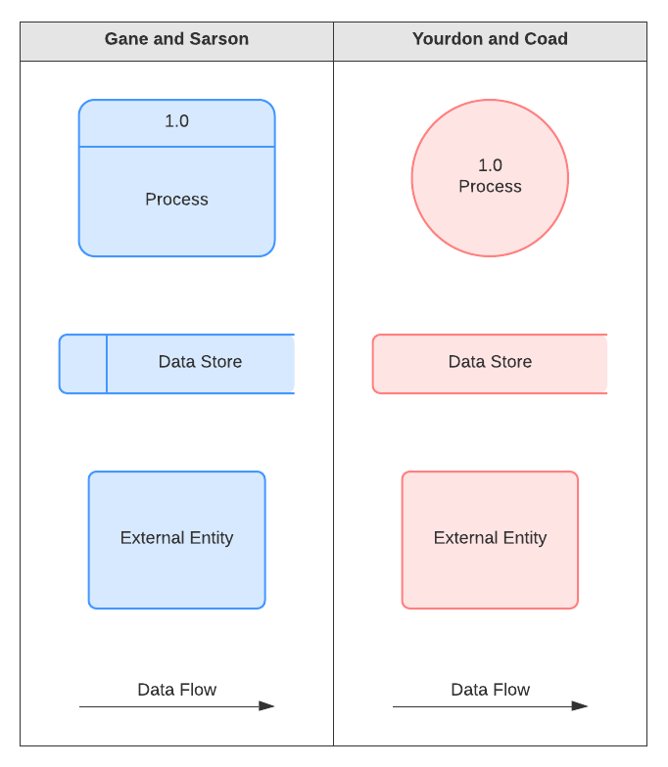

Figure 2.1. Component of DFD

## DFD ANALYSIS: DESIGN MAIN FUNCTIONS OF SYSTEM

* Login

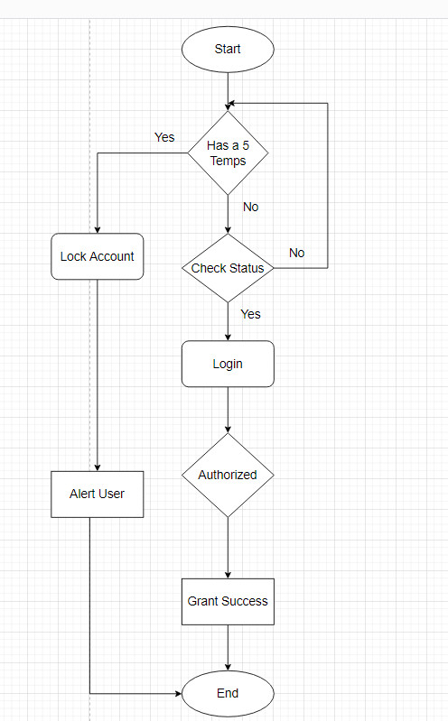

* Register

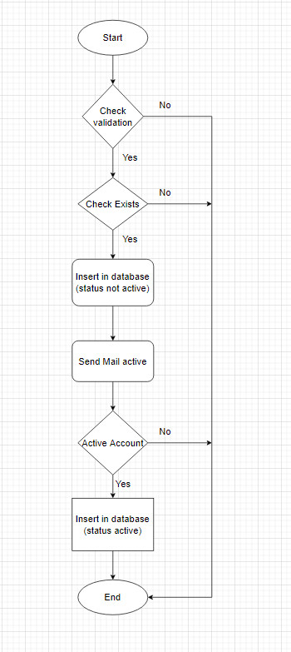

* Change password

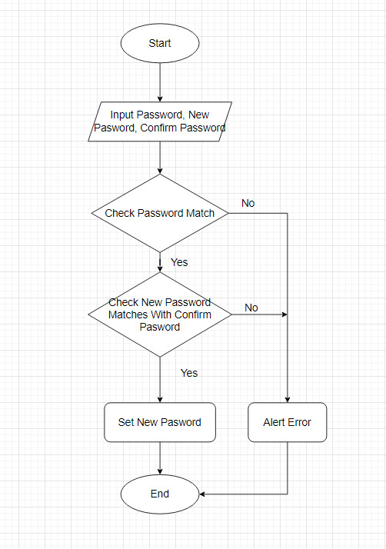

* Reset password

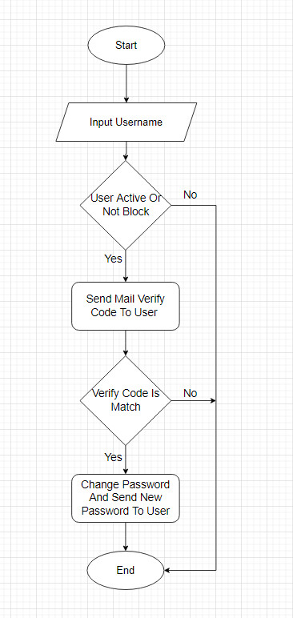

* Purchase package

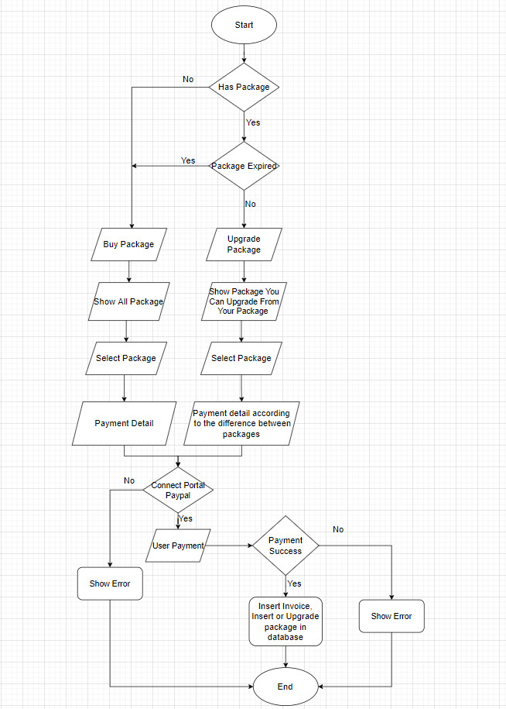

* Create news

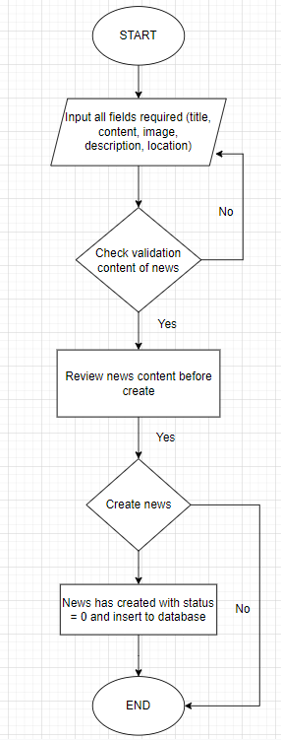

* Posting news

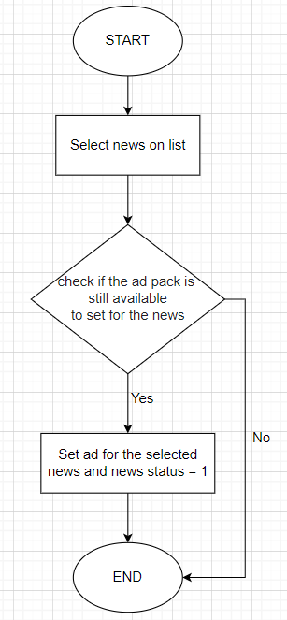

* Report management

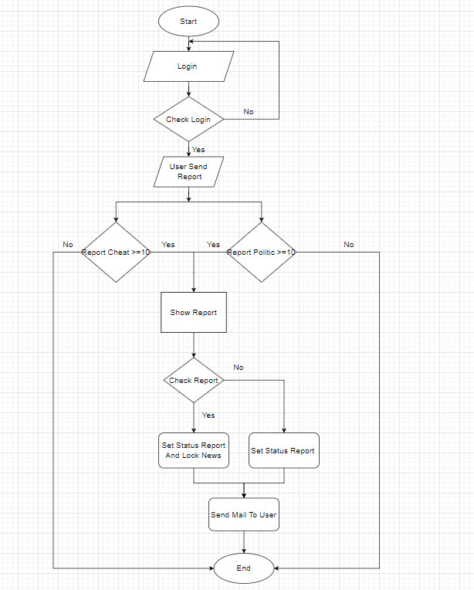

* Lock news

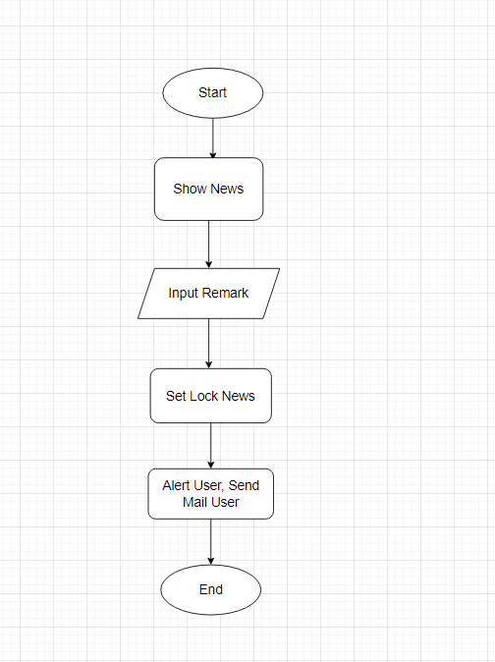

* **Live chat**

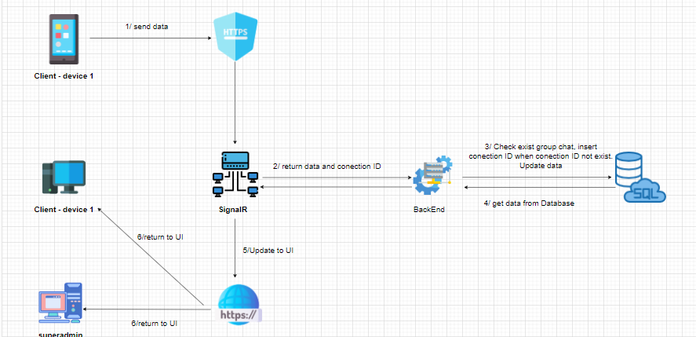

## DATABASE STRUCTURE

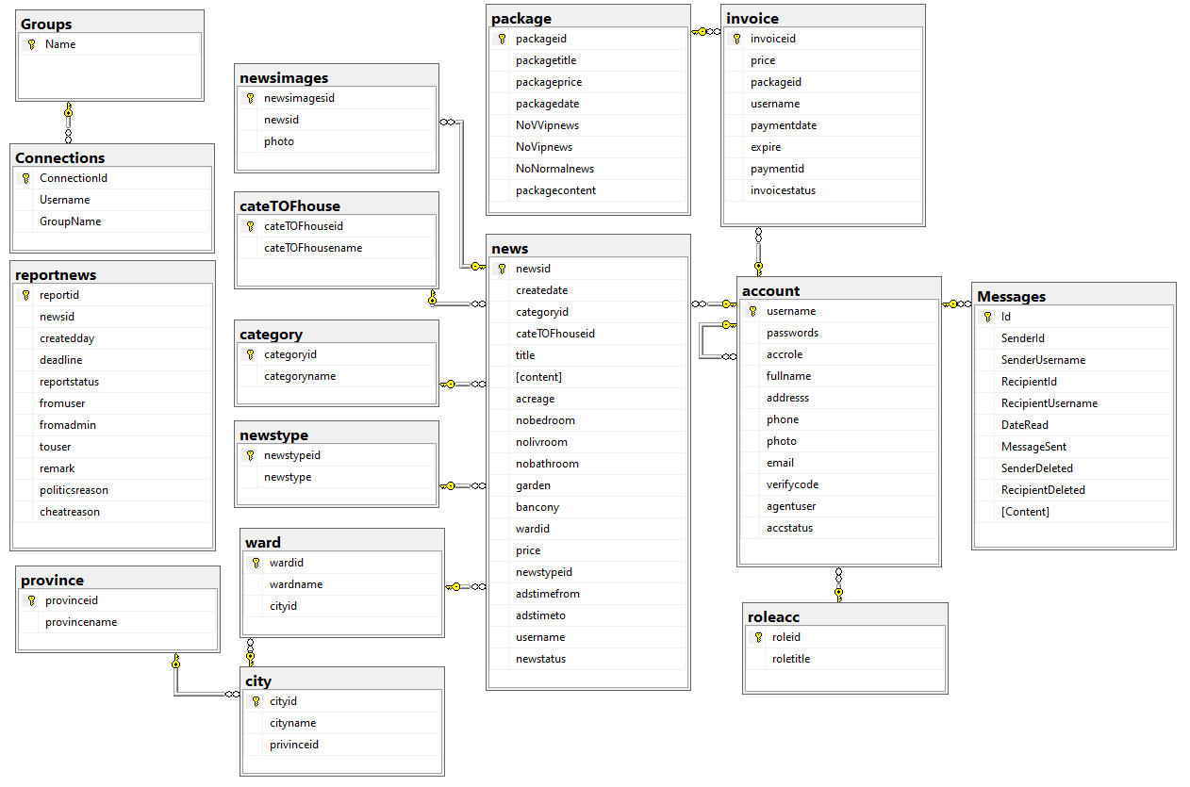



# CHAPTER 3: INTERFACE SNAPSHOT

## HOMEPAGE



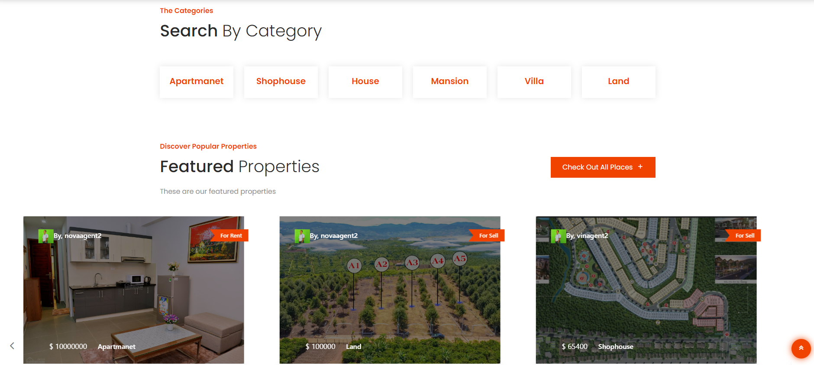

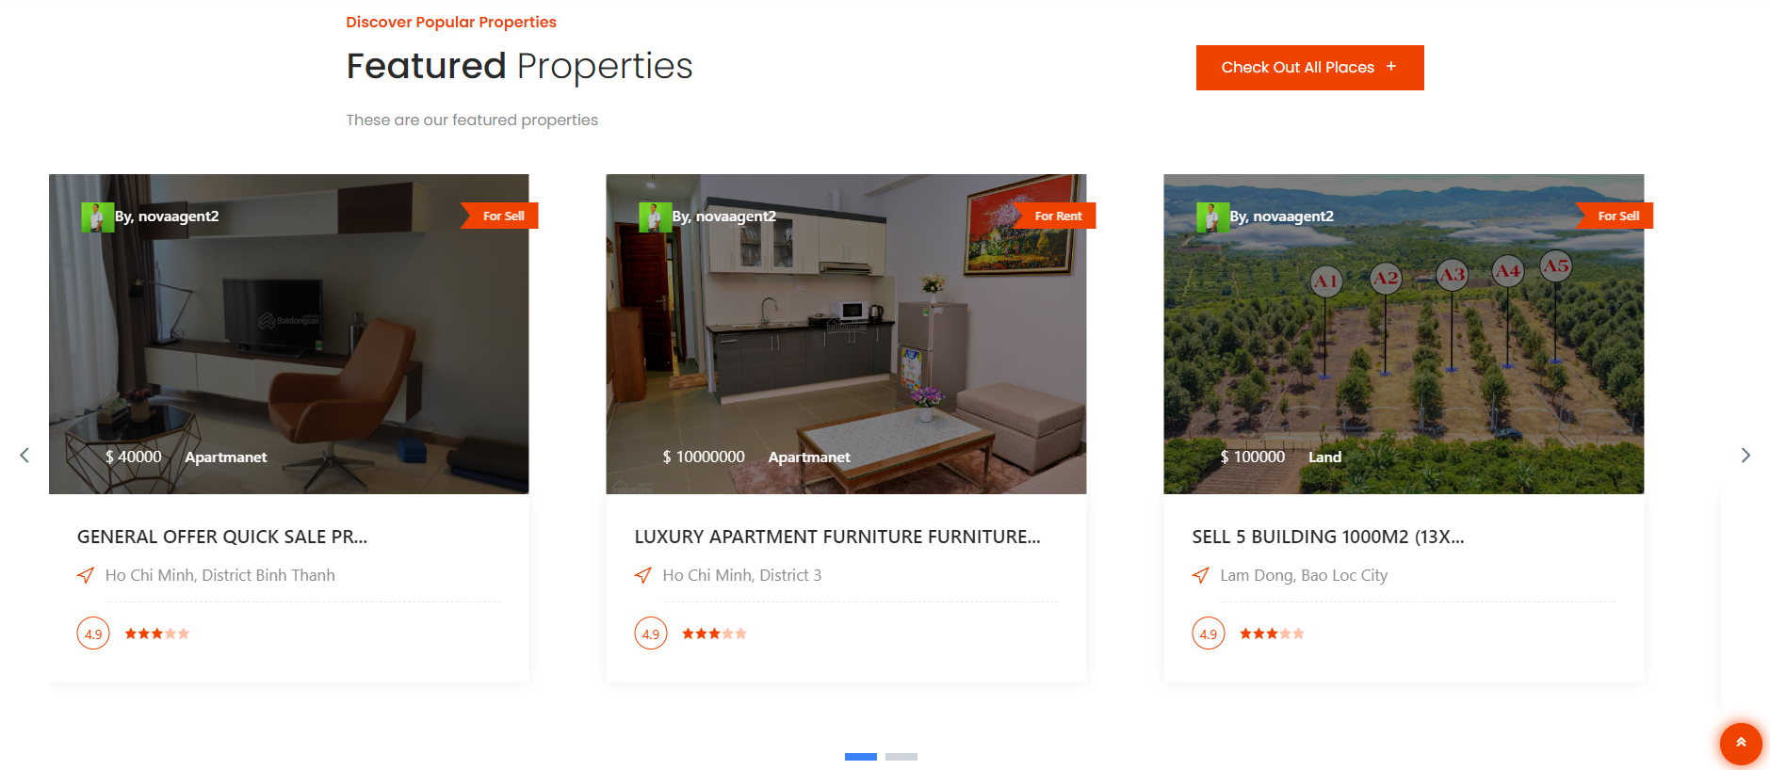

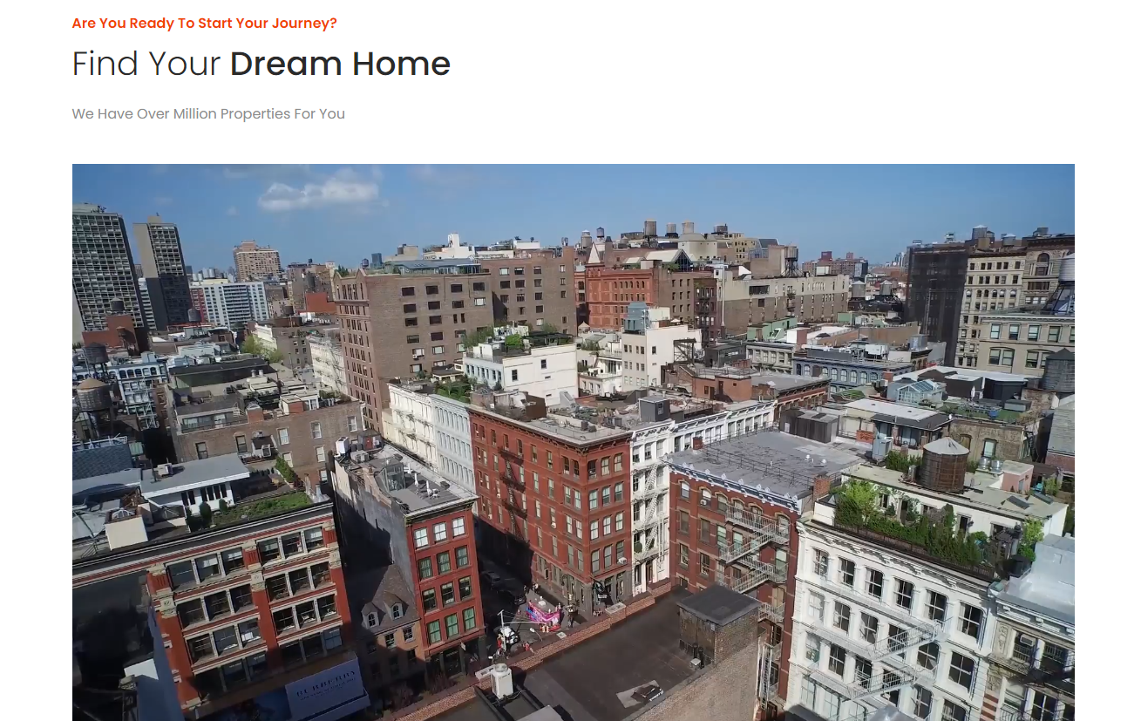

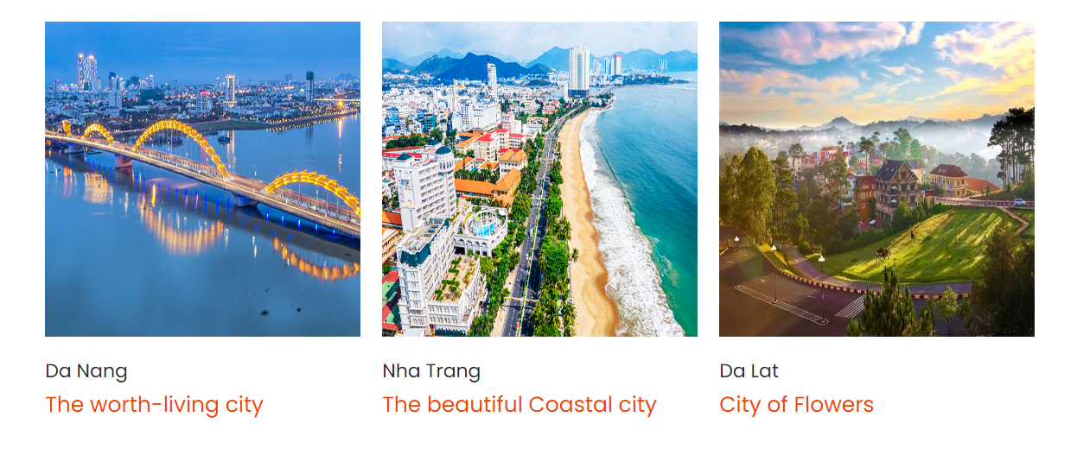

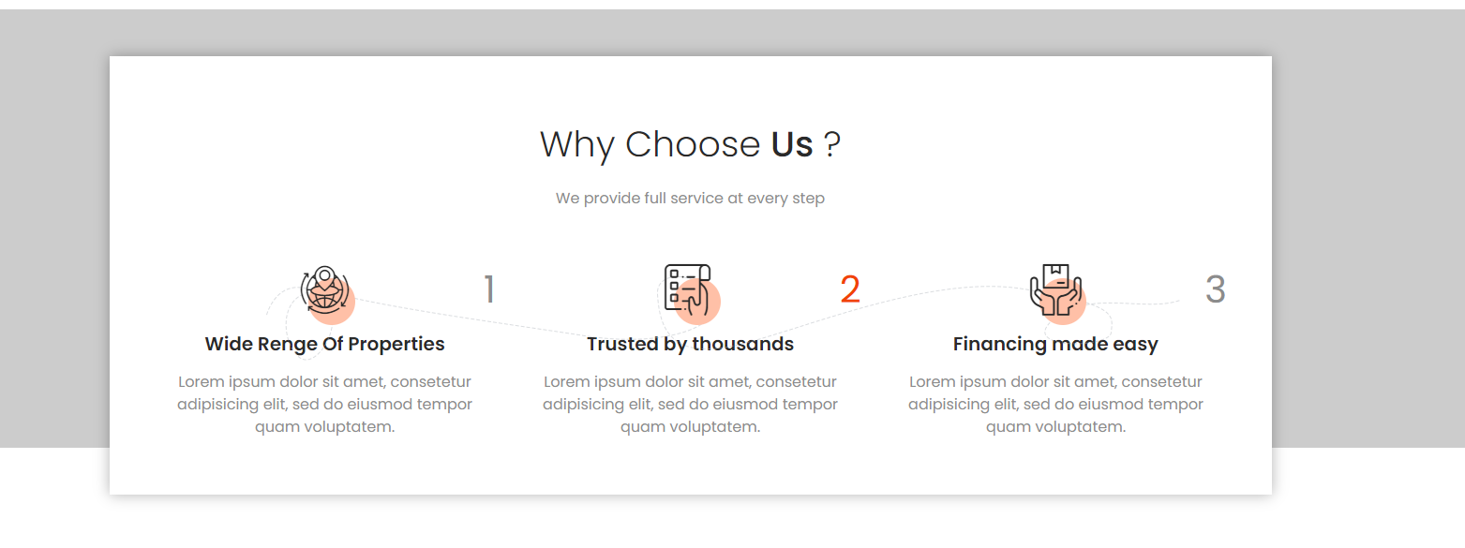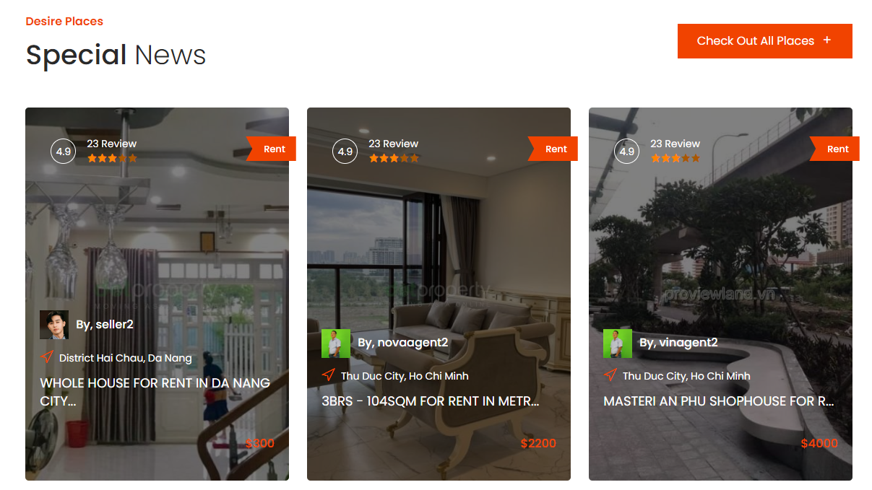

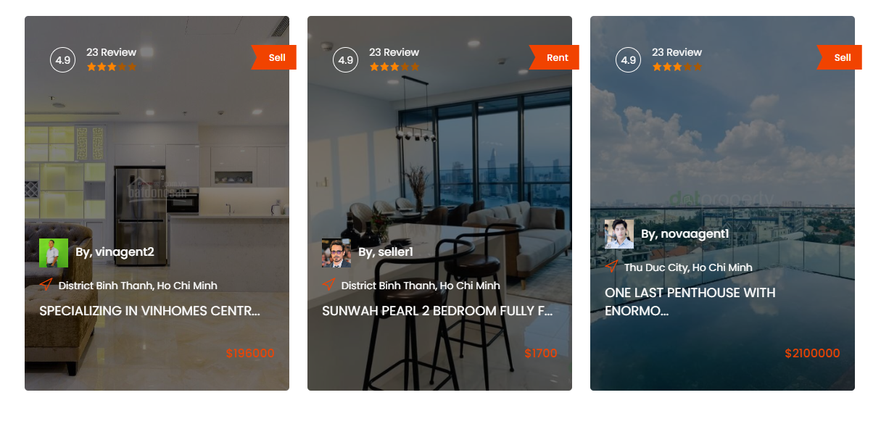

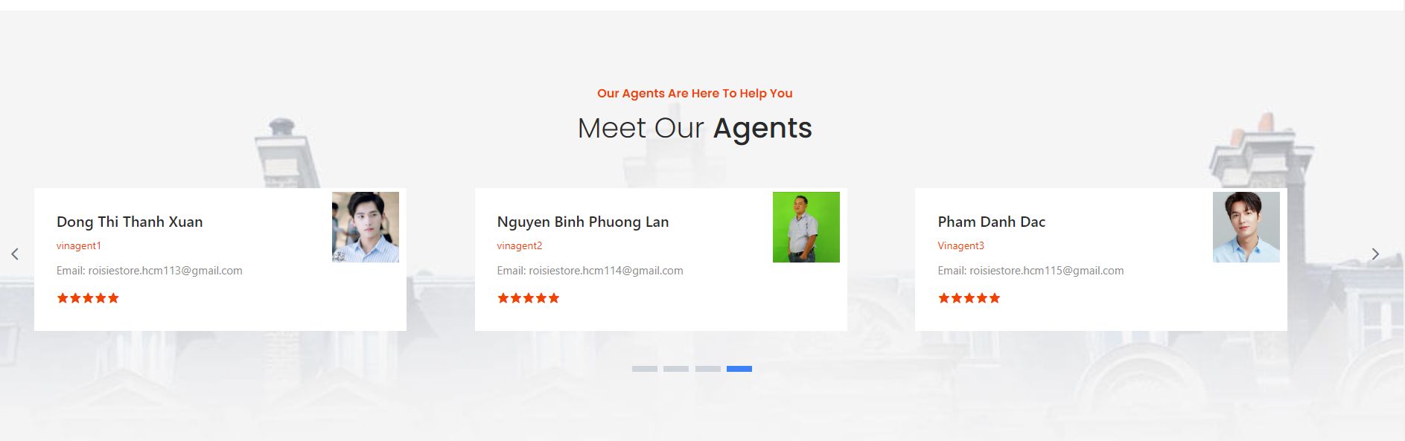

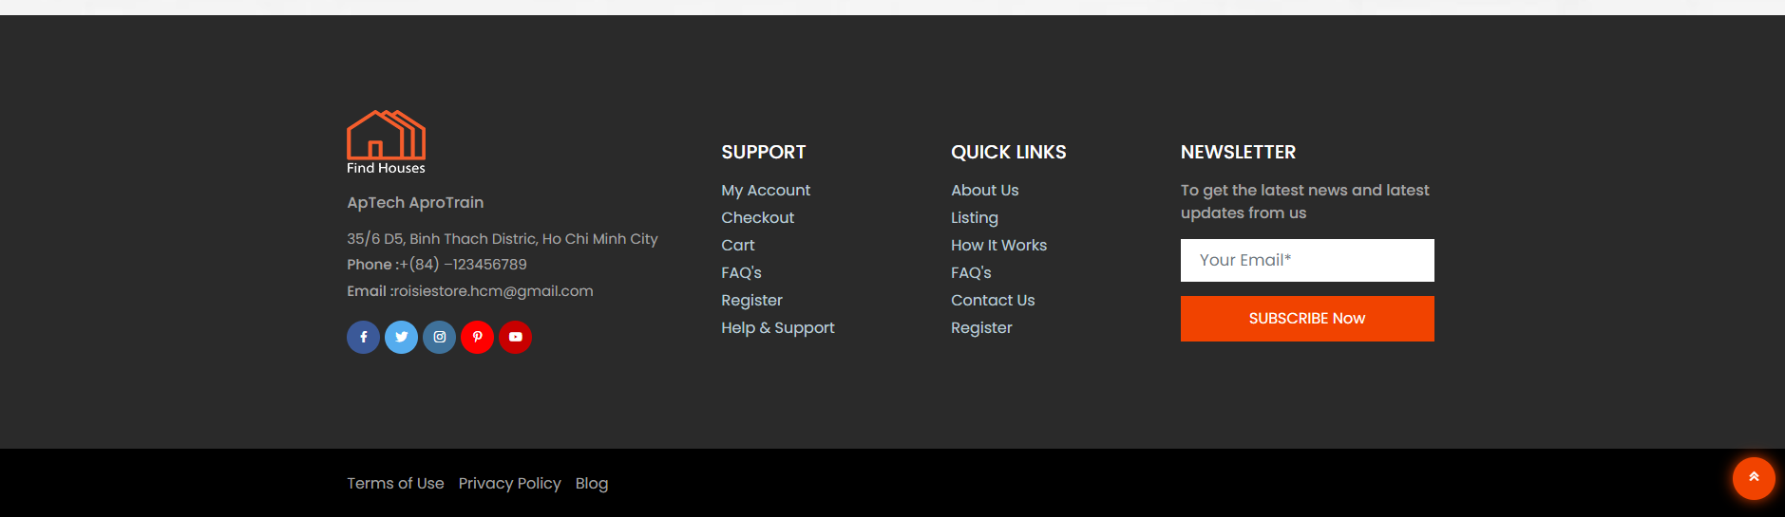

## LOGIN

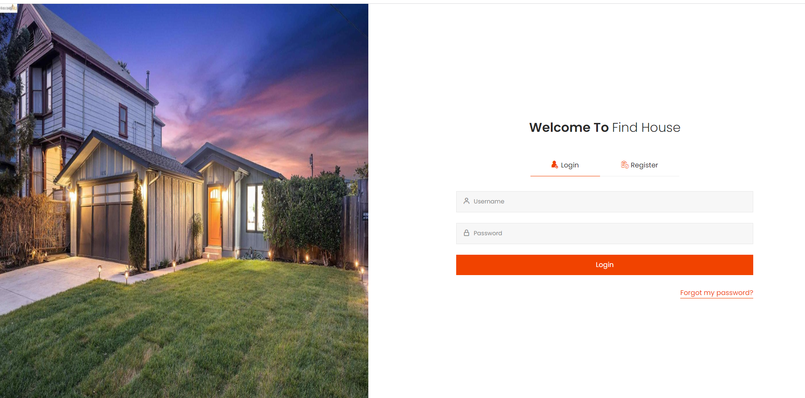

## REGISTER

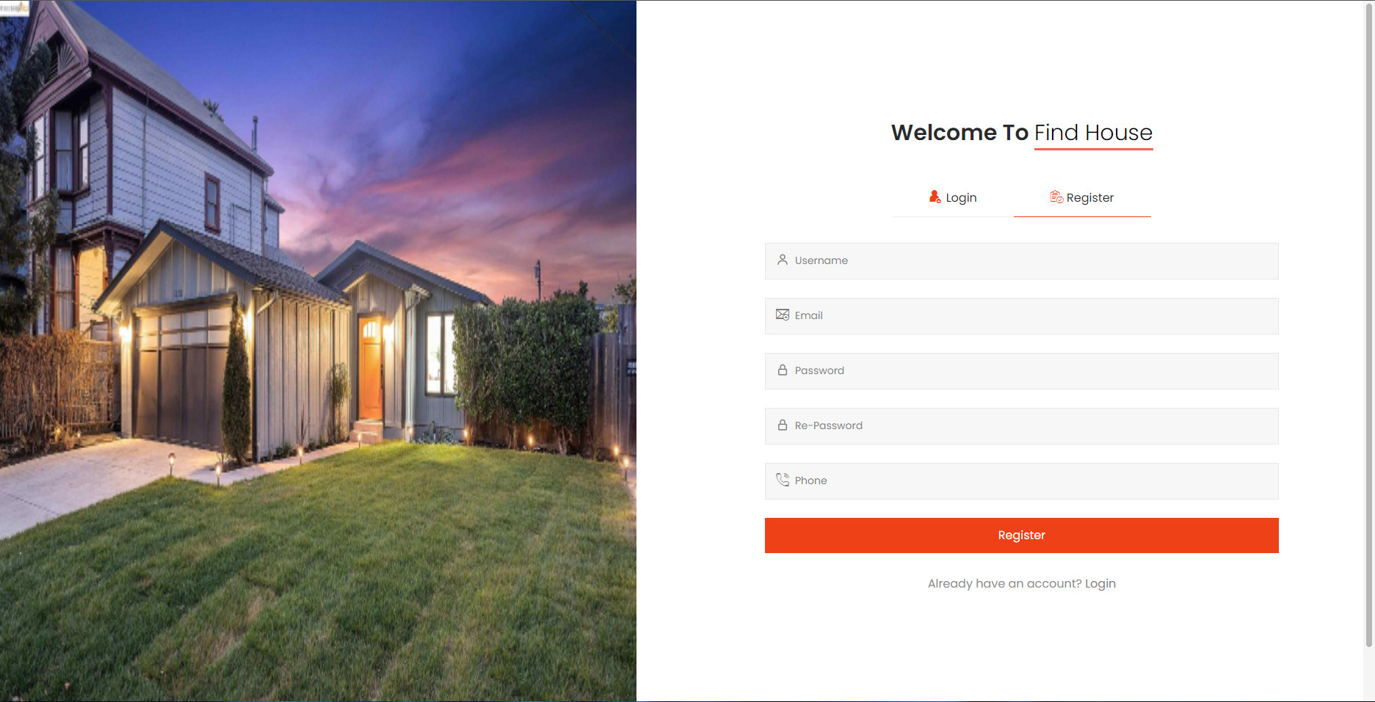

## NEWS

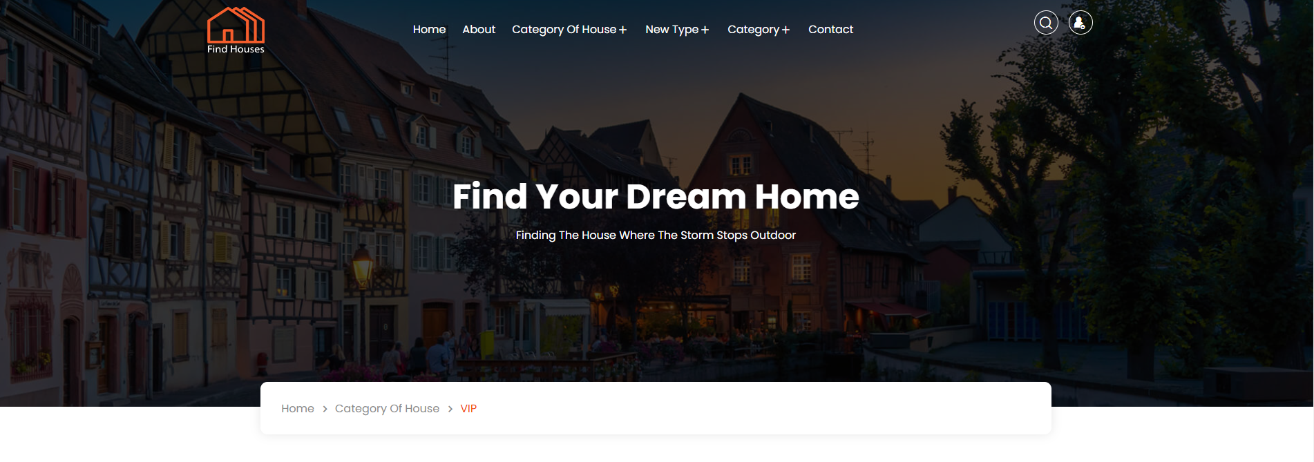

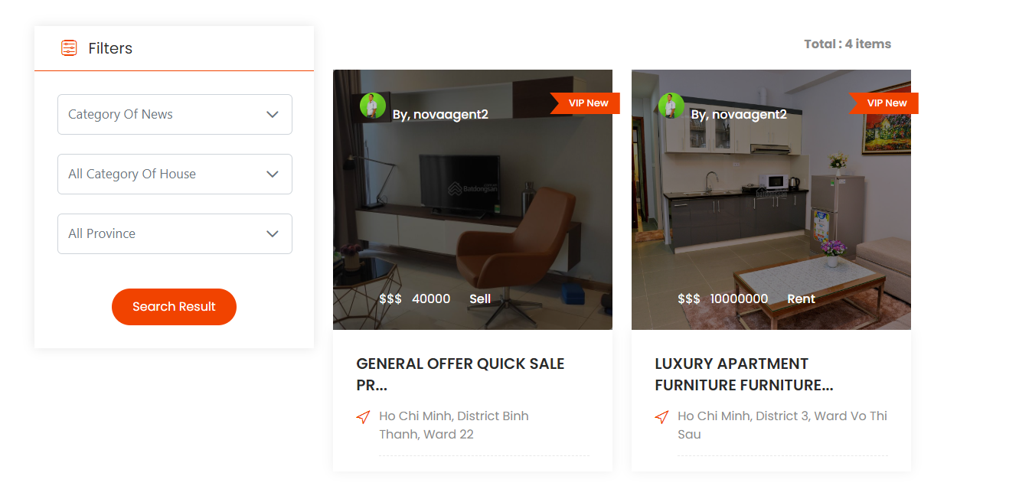

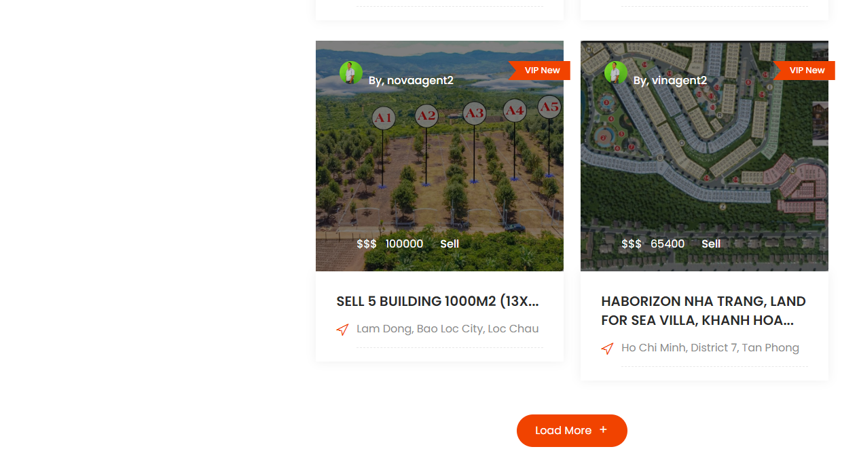

## NEWS DETAIL

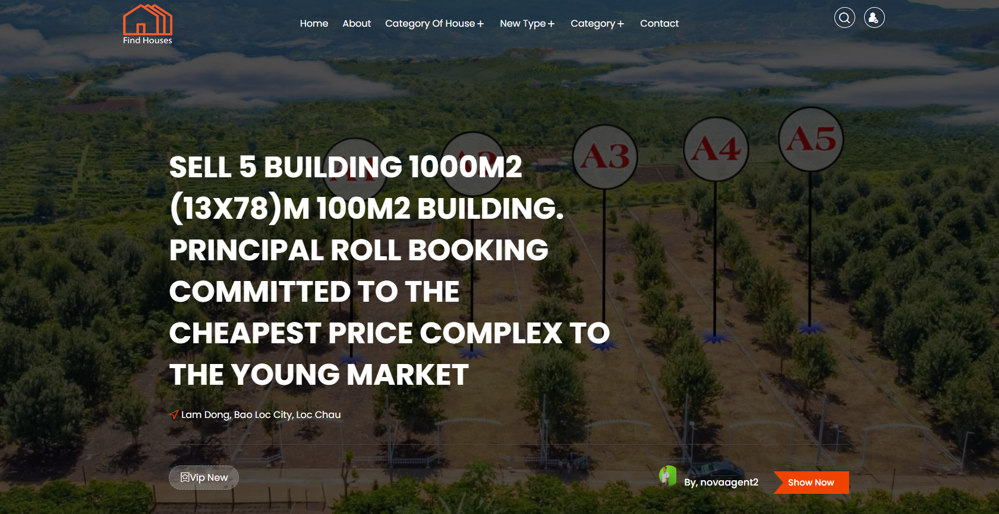

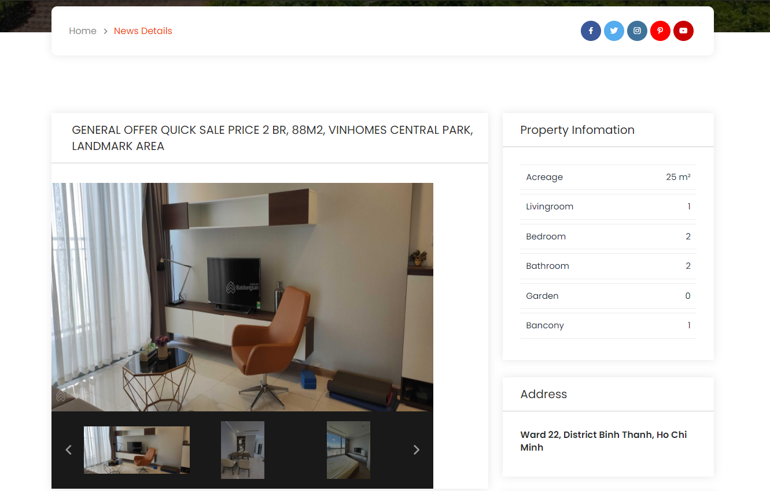

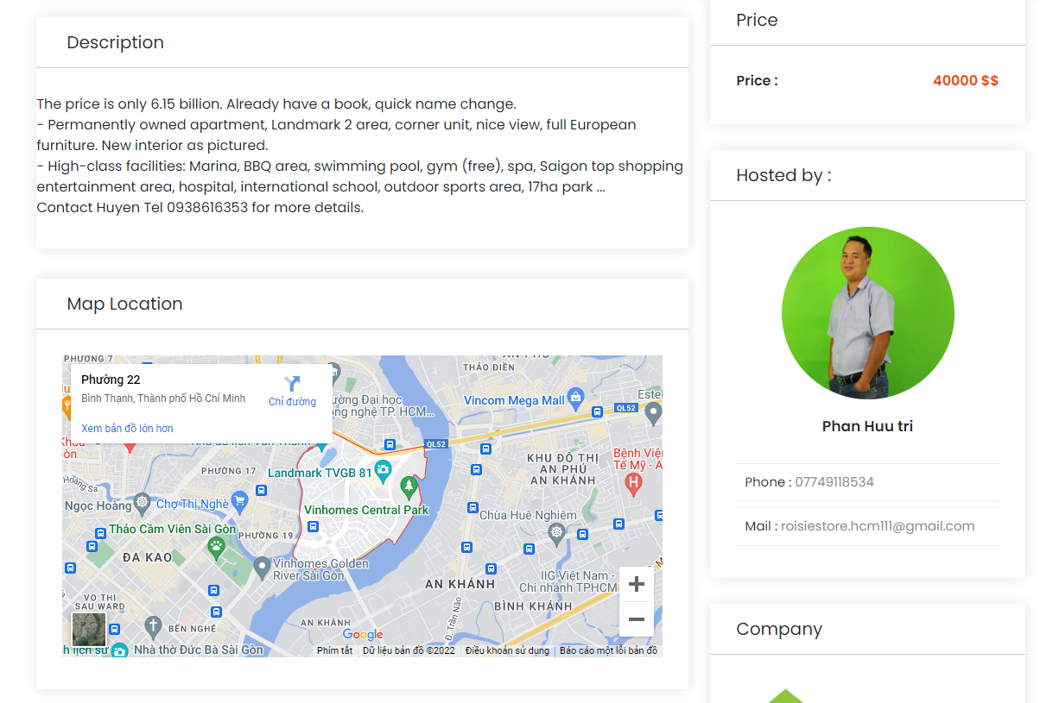

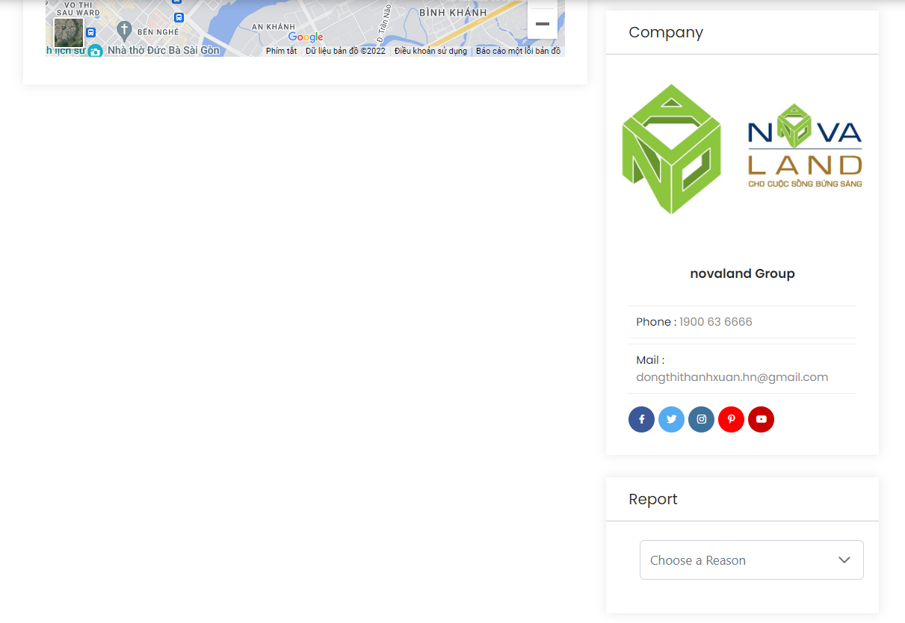

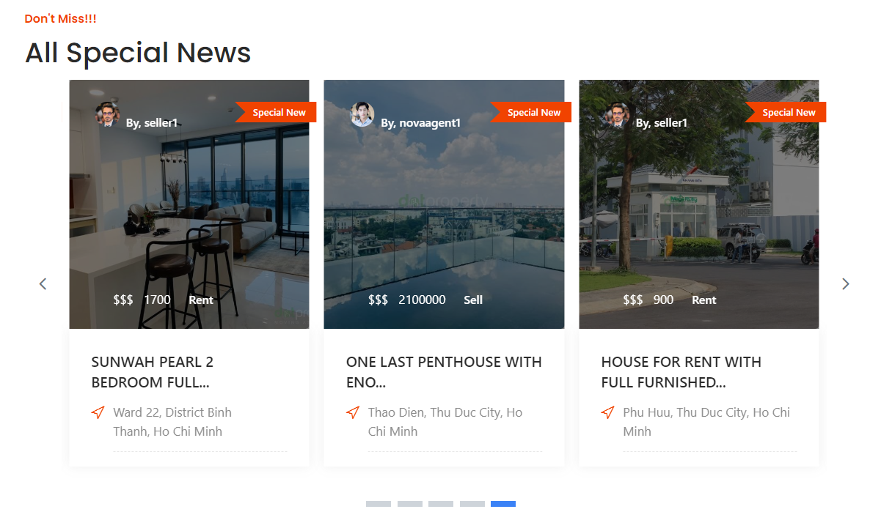

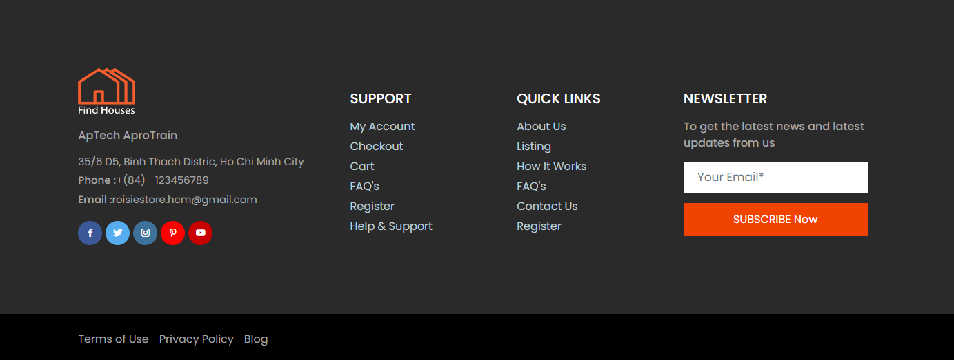

## CONTACT

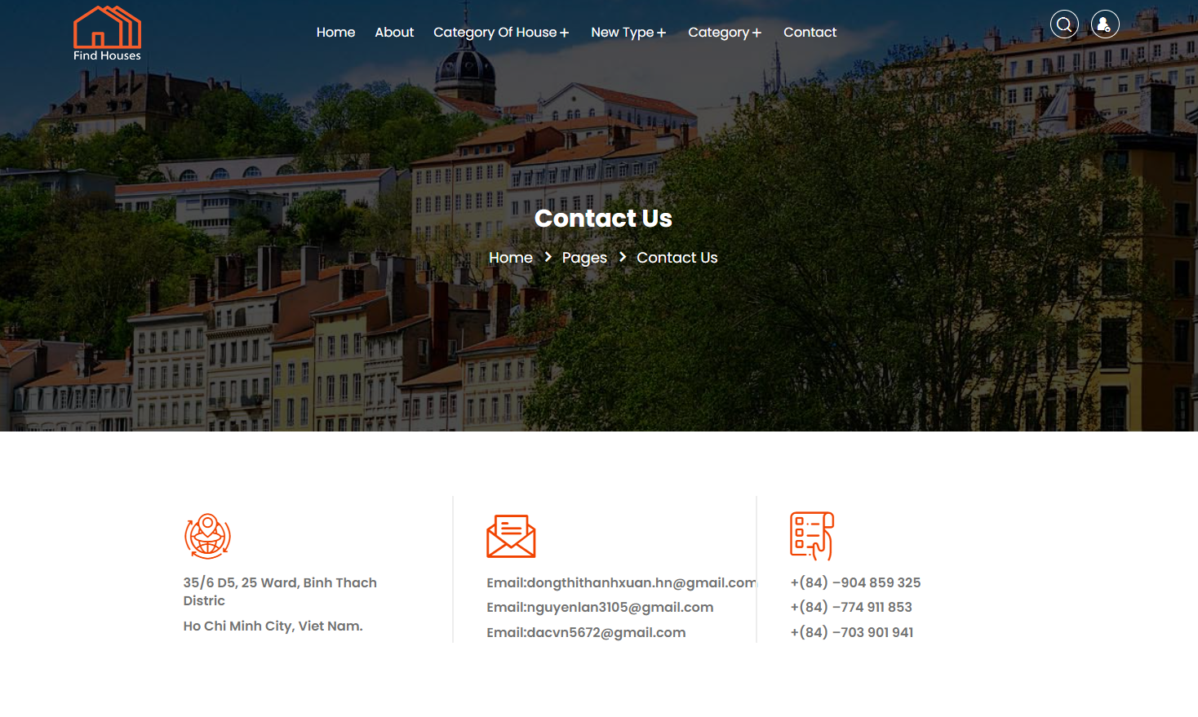

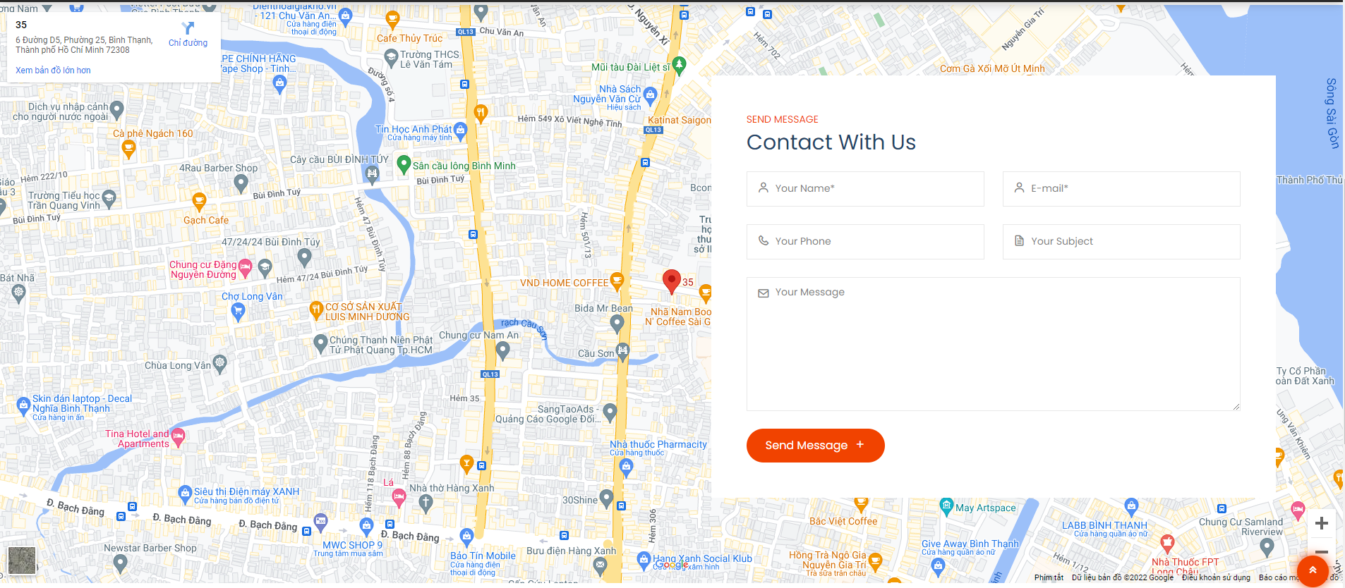

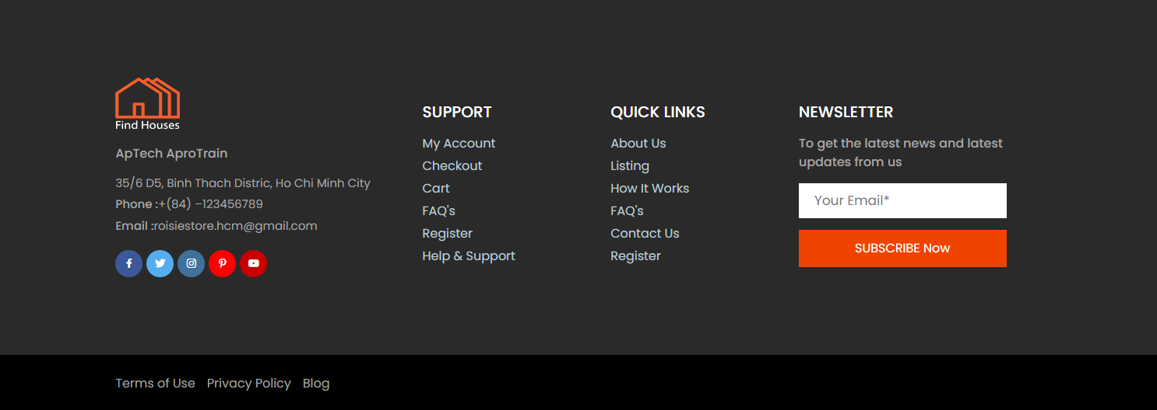

## VISITOR INFO

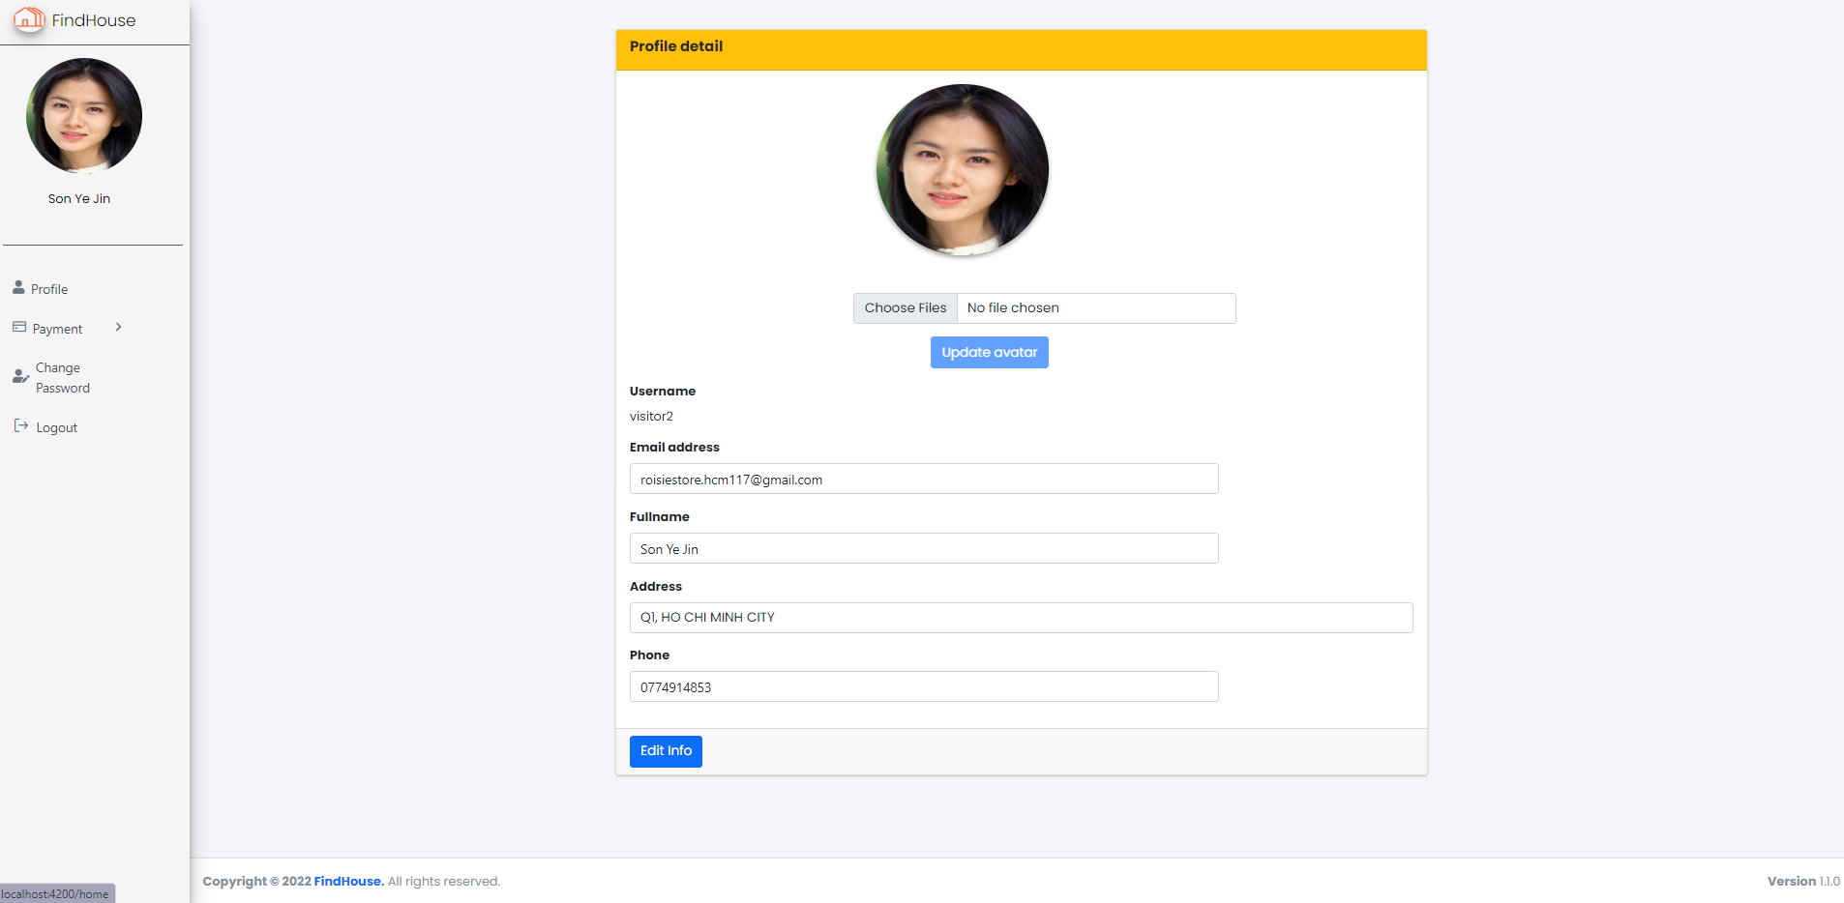

## ADMINPAGE

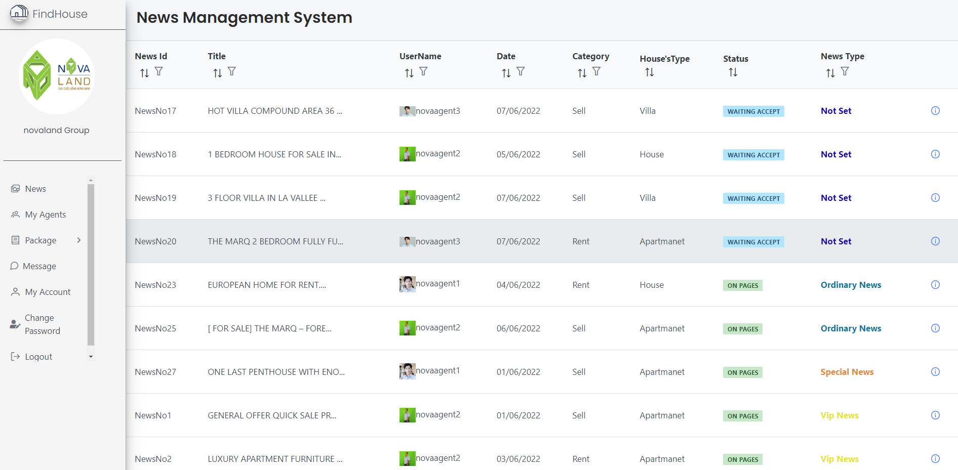

# colored rectanglecolored rectangleCHAPTER 4: USER GUIDE

## HOMEPAGE

#### Description

The homepage is the default page that will be displayed when the user visits the website. Homepage help visitors who visit the homepage need a way to understand what the website offers. Homepage include some element such as:

* News is classified by category with images and location of real estate.
* Display news by news category such as featured news, special news, …
* Search real estate news by category, location,…
* Contact page which will have all the information for customers to keep in touch with the company.

#### Design and operation

* Navbar function

Click here

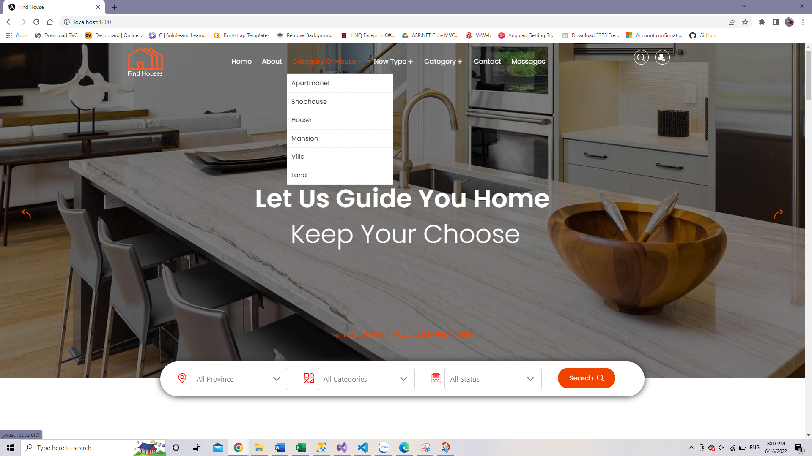

Category of house: click on Category of house on header menu user will be directed to the page of display news list by category of real estate such as: apartment, house, villa, shophouse,..

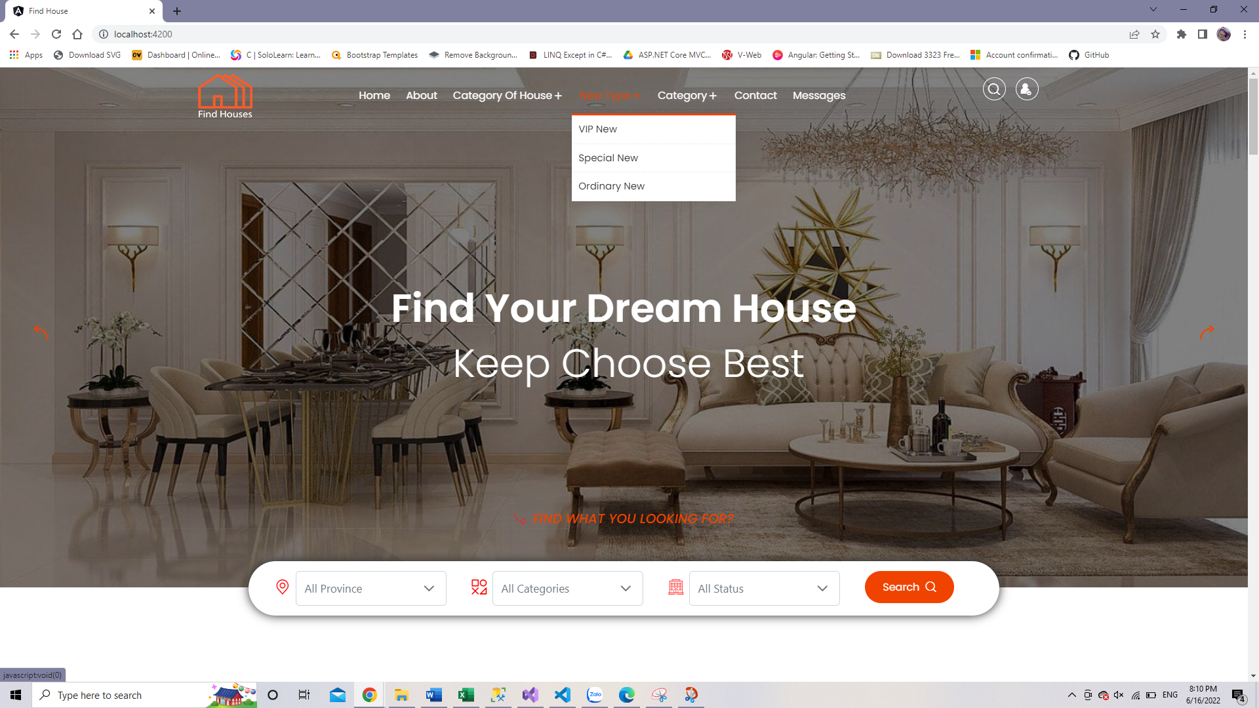

Click here

News type: click on News type on header menu user will be directed to the page of displays a list of news based on the subscription package that the publisher has purchased.

Click here

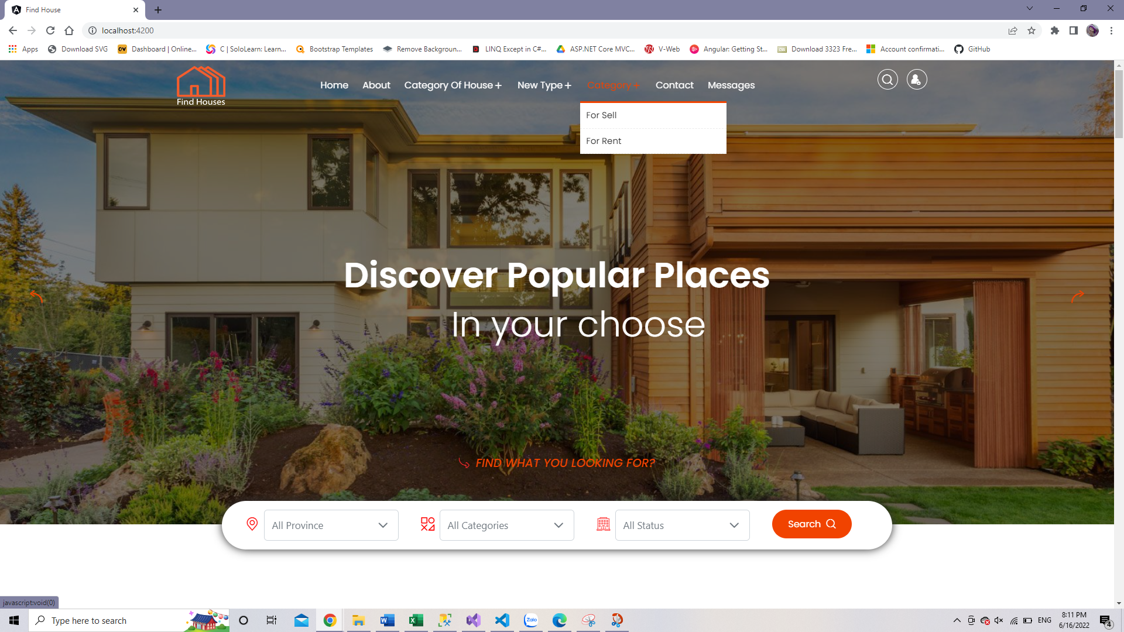

Category: click on Category on header menu user will be directed to the page of display news listings based on the status of the property: for rent or for sale.



Click here

Message: allow users (requires login) to chat online with super admin

* **Button fuction**

Click here



|  |  |
| --- | --- |
| Button | Function |
|  | **S**earch and display all news with title and content containing keywords |
|  | Click this button to sign in your account or reigister an account if you don't have an account yet. |
|  | When users log in this button will be displayed your avatar and you can access your profile info or purchase package if you want to posting news. |
|  | When users log in this button will be displayed and when access is no longer needed, the user can log out. |

* **Search fuction**

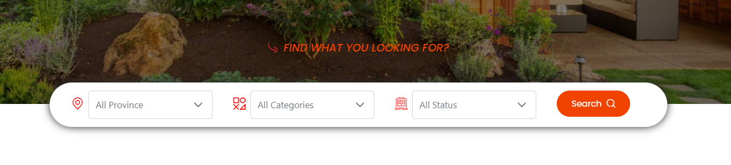Search for real estate news based on the area, type and status of the property.

## REGISTER

#### Description

Users are not required to register to be able to view news, but if they want to post news, users must register for an account.

#### Design and operation

If you don't have an account then click on the log in button and it will direct you to the account registration page.

When a user registers, the user will be registered as a visitor. Once visitors buy an advertising package, they will have the right to post news on the website as a private seller. Super admin will have the right to create an admin and then the admin will create their own agents.



* Register informaion:

|  |  |
| --- | --- |
| Username | * This field is mandatory. * This field will be used as login credential along with customer’s password. * Username must include: not pass 25 characters alphabet, do not allow blank space, special character and unicode. * Username must be unique in the system. |
| Password | * This field is mandatory. * This field will be used as login credential along with customer’s username. * Password must include: at least 6-10 characters, must have at least one special character, a number, one uppercase and one lowercase. |
| Confirm Pass word | * This field is mandatory. * This field must be matched with the “Password” field. |
| E-mail | * This field is mandatory. * Must be an correctly e-mail address. |
| Phone number | * This field is mandatory. * Must be an correctly phone number: not allow alphabet and special character. |

Upon successful account creation, the activation email will be sent to the registered email. Click active to activate your account.

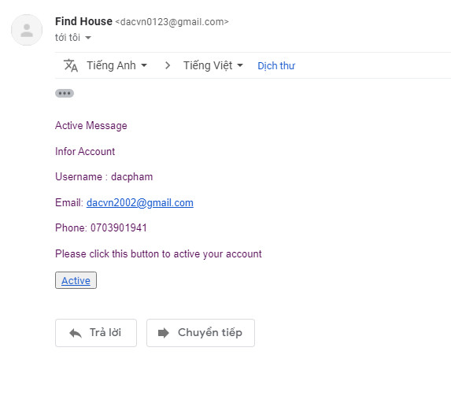

## LOGIN

#### Description

Once the user is logged in, they can access features such as reporting news or subscribing to buy advertising packages to post news. Howerver, if user enters the wrong password 5 times in 5 miniutes, the account will be locked and the user need to contact admin to unlock account. Each account registered with a different role will have access to separate features.

#### Design and operation

* Login

Users can log in when click on the user icon and the website will direct them to the login page, then just enter the exactly username and password to access their account.

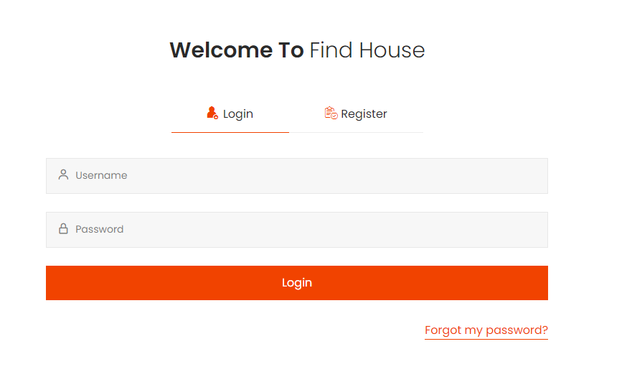

|  |  |
| --- | --- |
| Username | * This field is mandatory. * This field will be checked if this username is registered and matches the password registered in the database. |
| Pasword | * This field is mandatory. * This field will be checked if this password is matches the password corresponding to the registered username in the database. |

Once the user is logged in successful, the user can access the user’s site and purchases advertising packages to posting news, review orders package, account info,etc.

* **Forget password**

If you forget your password to log in, click to “Forgot my password?” and a pop-up will display that help you retrieve login information. If you forget your password to log in, click on “Forgot my password?” and a pop-up will display that help you retrieve login information. Users need to fill in the user name to password retrieval.

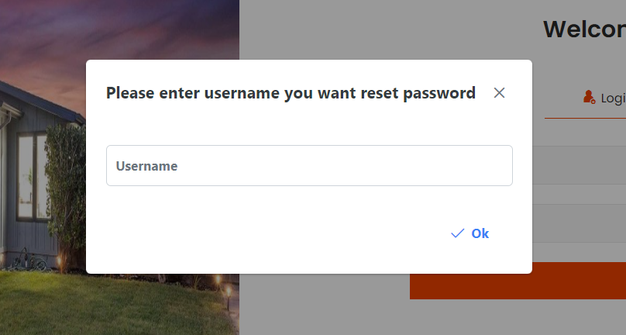

User need to enter username and the verify code will be sent to the mail and the user needs to enter this code exactly in the confirmation box, and a new password will be sent to the mail. User will use this password to login again and can change another password after login.

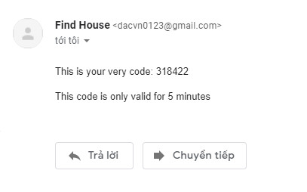 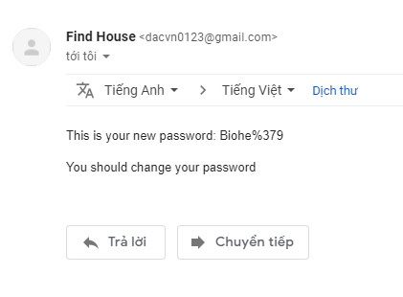

## PROFILE INFO

#### Description

Once user log in successfully, users can view and edit their personal information, purchase advertising packages to posting news, change avatar, password.

#### Design and operation

Click here



This is the visistor’s account site:

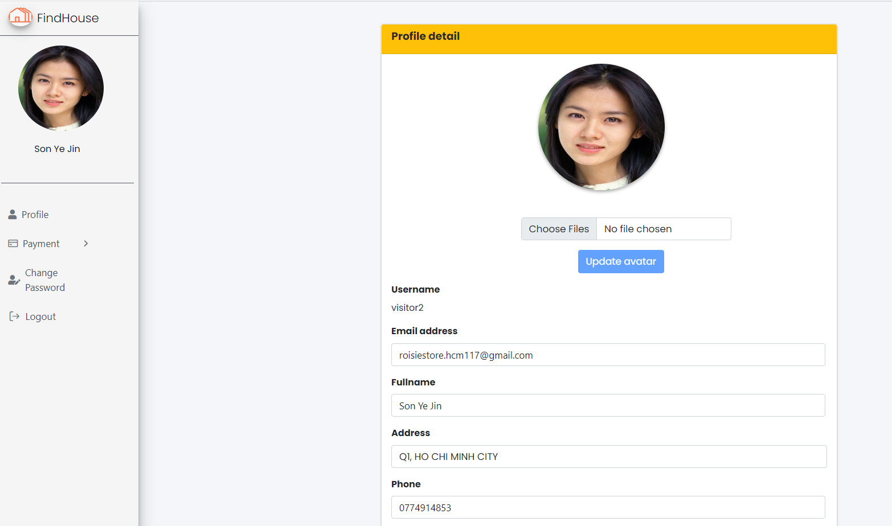

**Profile**: This site will show all information about user’s info such as: username, fullname, phone, e-mail and user also edit their information or change avatar.

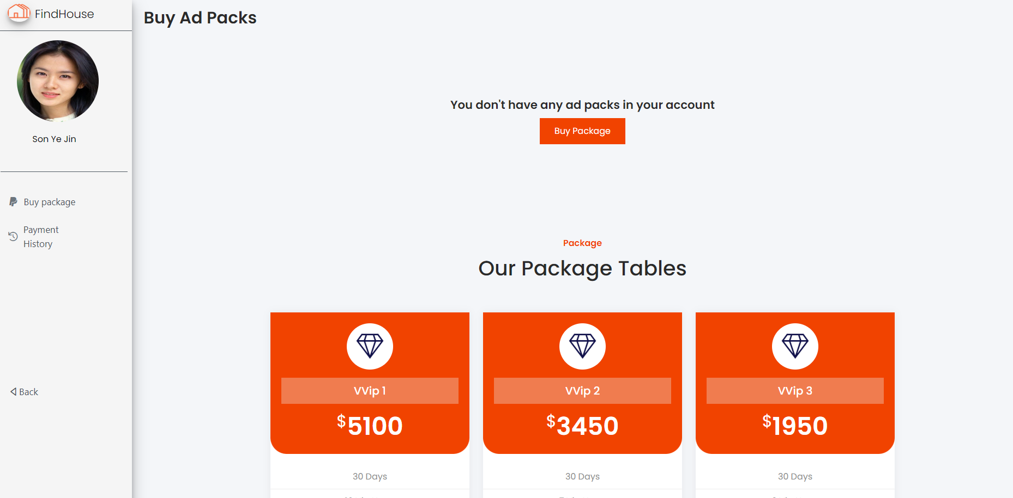

**Payment**: Users can choose to subscribe to news packages if they want and the payment will be made through paypal.

Currently on the website there are 15 types of news posting packages for users to choose based on their needs.

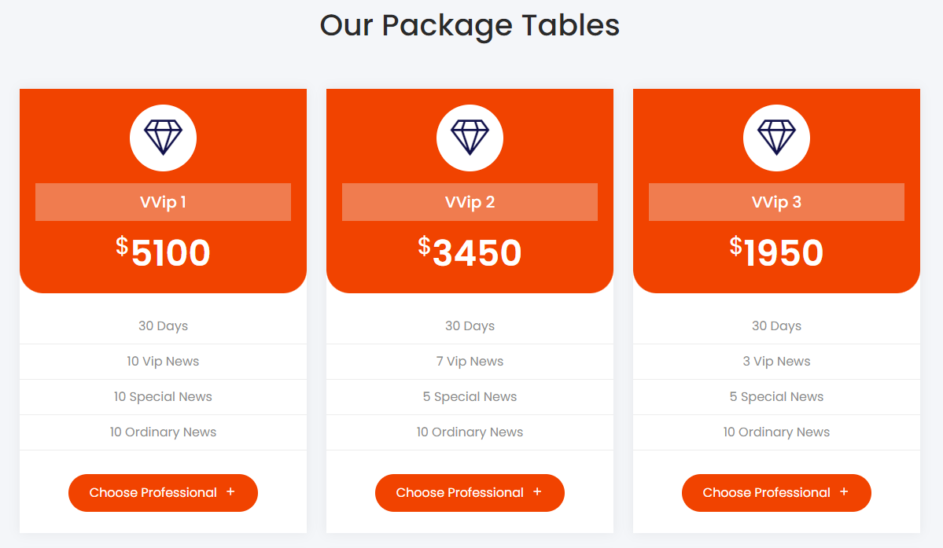

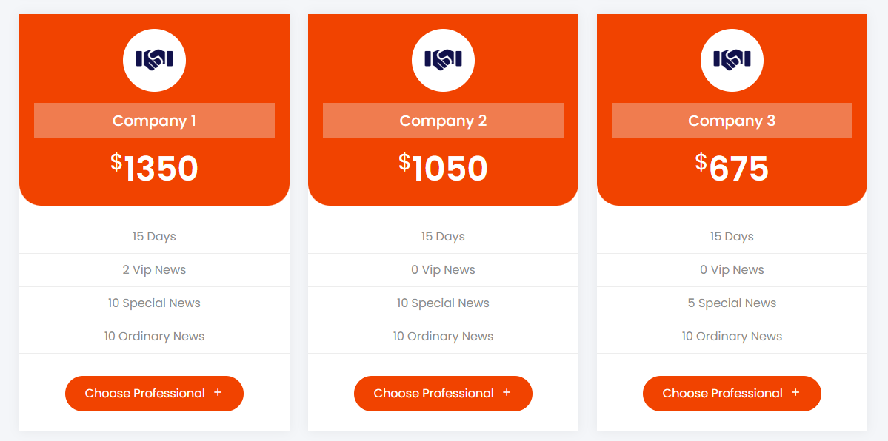

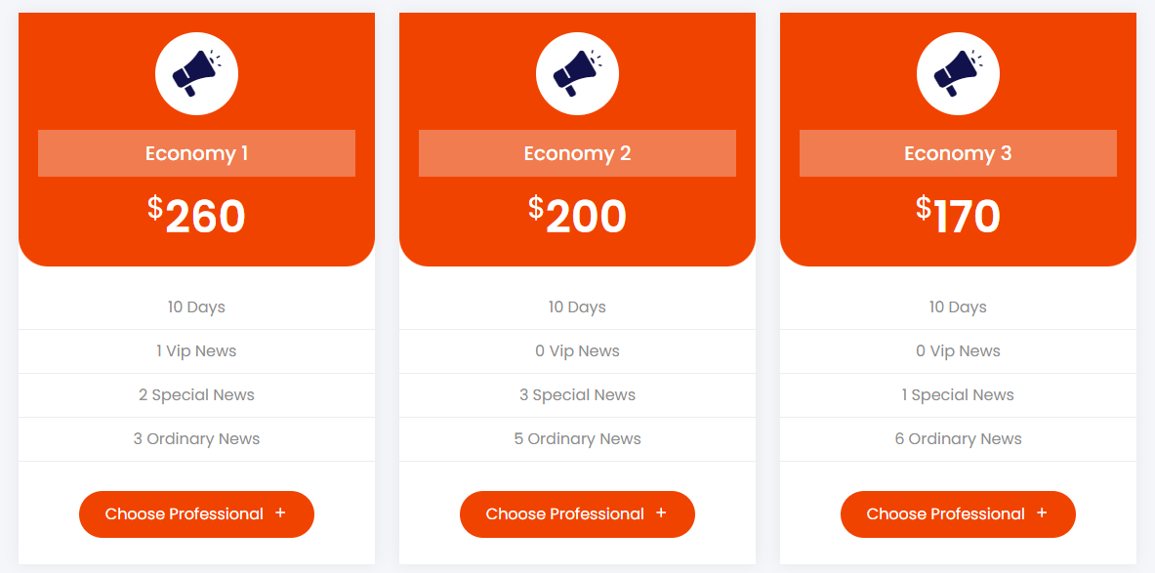

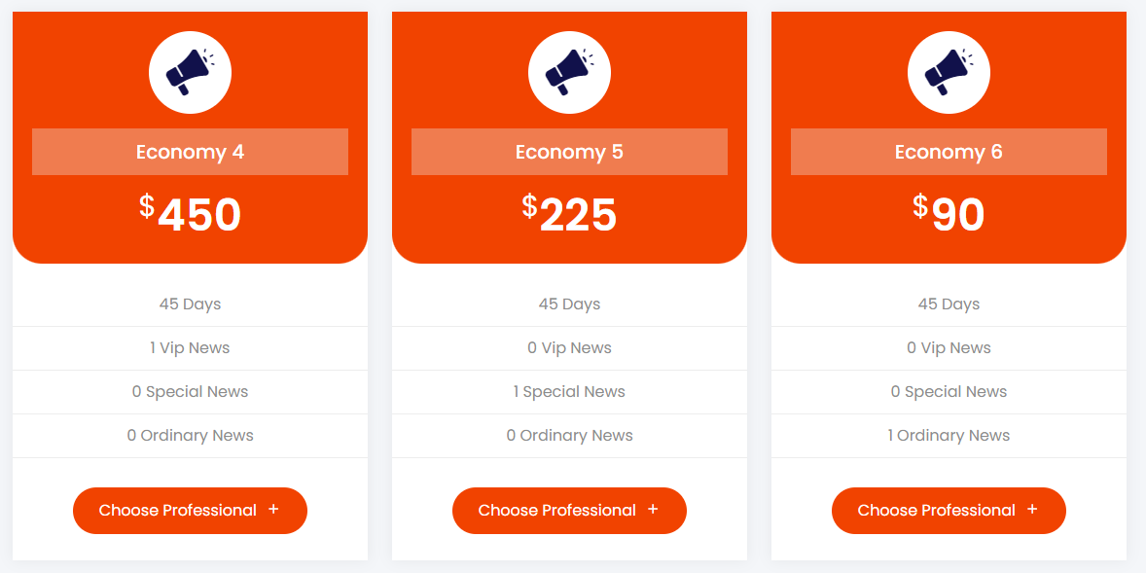

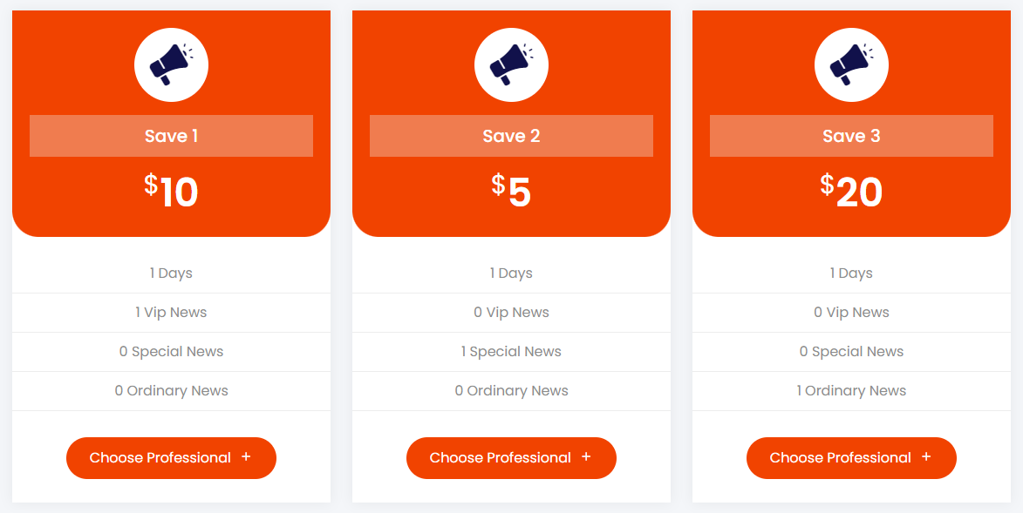

When a user chooses to buy a package, the website will navigate to the shopping cart page to make an order.

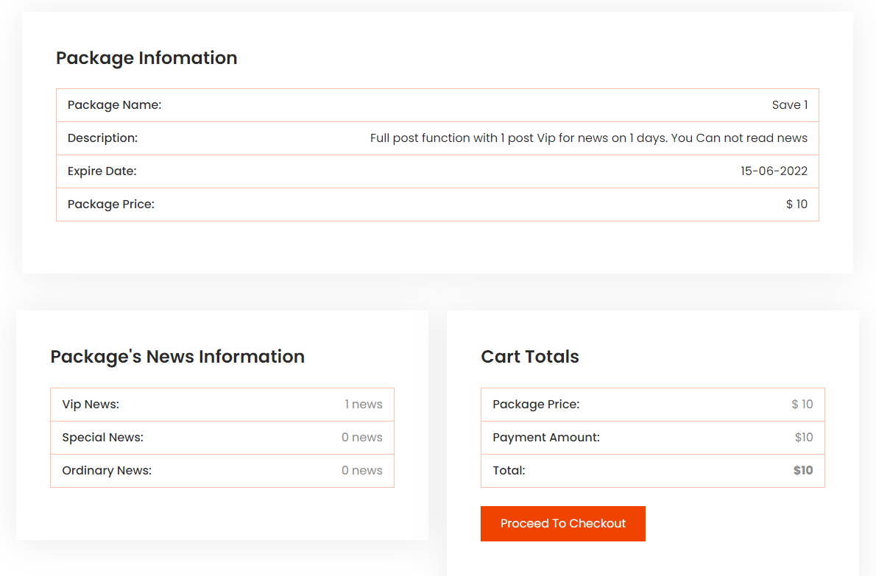

Click here

After checking the correct information, the buyer will click on “Procceed to Checkout” and proceed to pay on paypal.

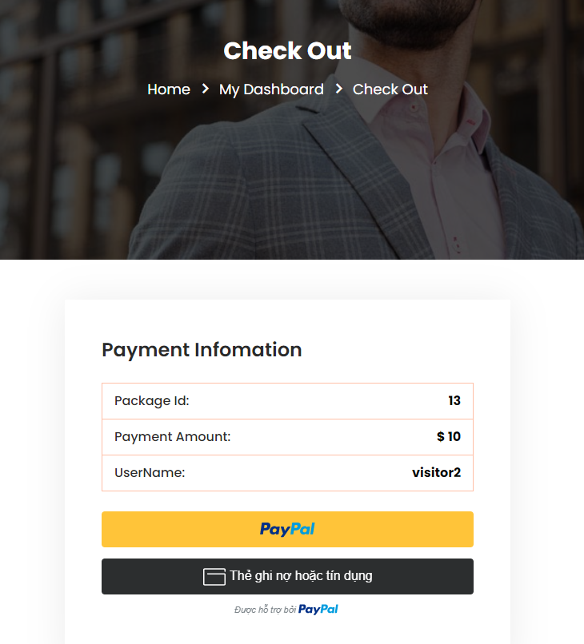

Click here

Log in to your paypal account and proceed with the payment.

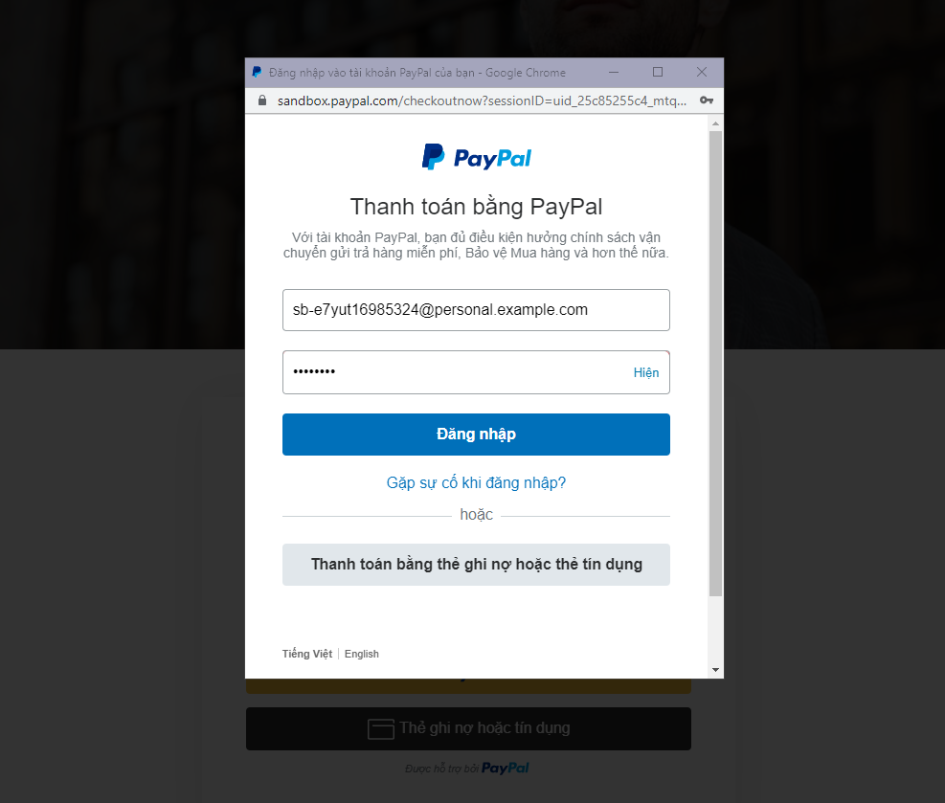

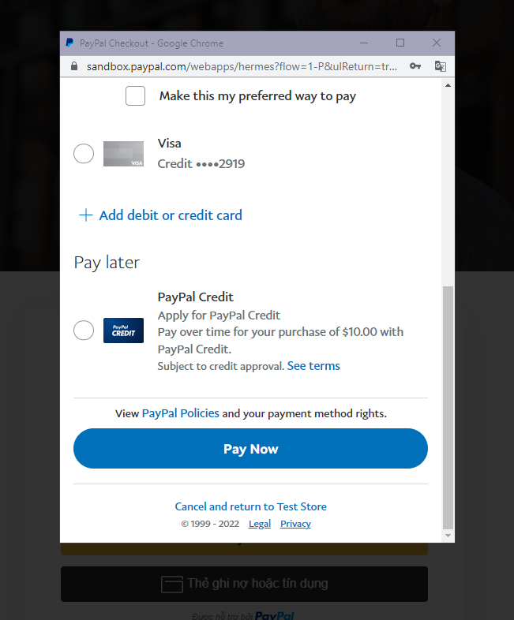

Once the payment is successful, the user is asked to log in again to start posting as a private sale.

**Histrory payment**: shows all the user's purchases of advertising packages on the website.

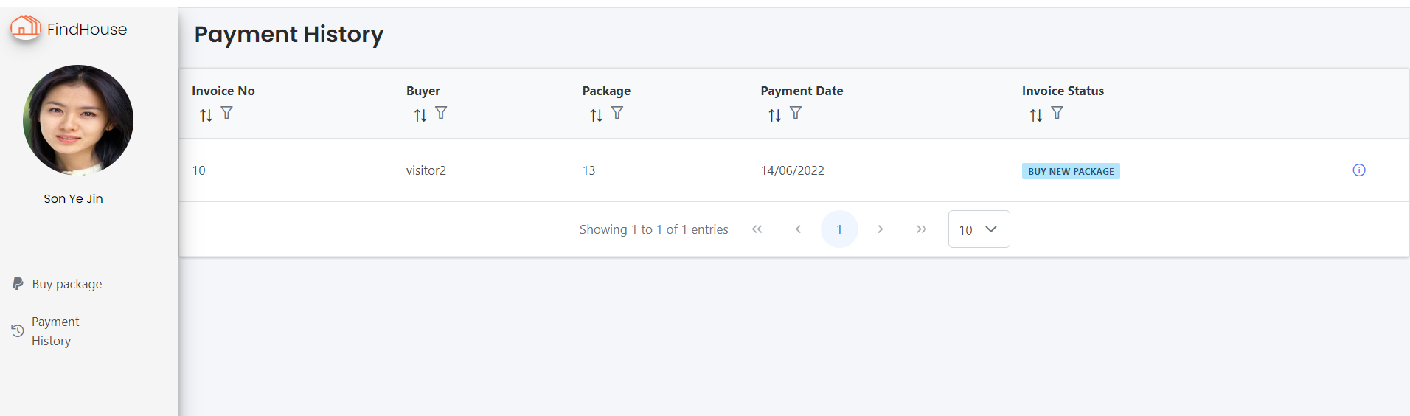

**Change password**: users can also change the password for their account.

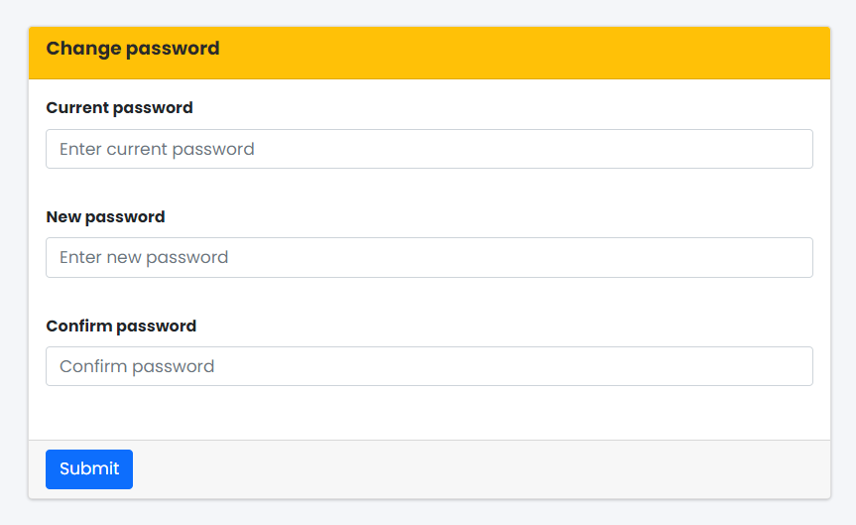

## LOG OUT

#### Description

User can log out when access is no longer needed.

#### Design and operation

When users have already signed in, there-s an icon log out will display on the header menu. Clicking on the icon and user can log out account from website.

Click here



## REVIEW NEWS

#### Description

Users can view the list of news categorized by category of house, type of news,... Each news has shown information like location, image, price, brief summary about the property. For detail, click on an item that will direct the user to view a detail page that shows the following information:

* Description, and detailed images about the property.
* Infomation to contact an agent or private sale.
* Related news.

#### Design and operation

There is various way to display the news depending on the user’s need:

* Use the search engine to find a location, type of property,..
* View all VIP news of hot real estate.
* View all special news
* Show all news related to the property users are viewing.

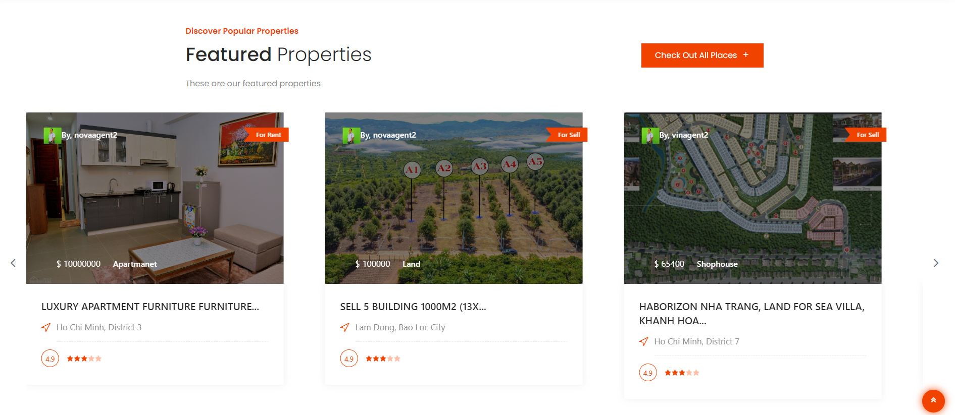

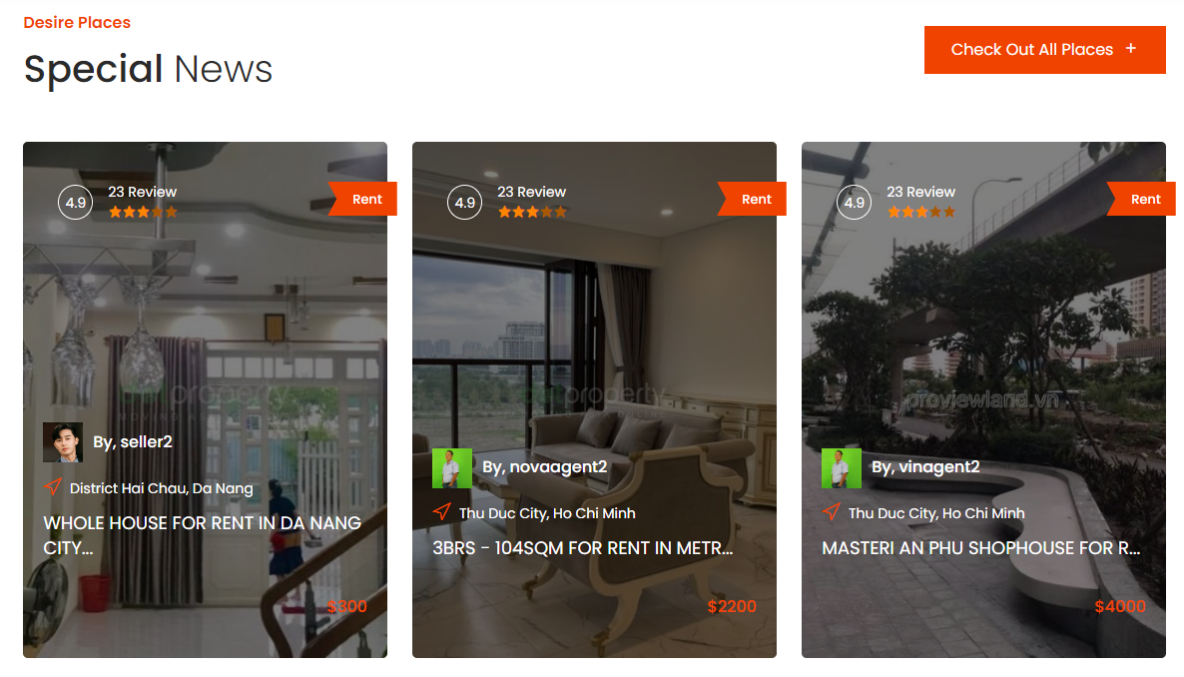

**News detail**: The details page will display information about the location, a description of the property, detailed photos, and contact information for the seller,...

**Report news**: You need to log in to use this feature. In this section, there is also a news report section if the reader find out this is fraudulent or politically related news and the report has been sent to the admin to check it. If the user has reported news for the same reason and the report is being processed, it is not allowed to report anymore. Users can only continue reporting if the admin has processed the report.

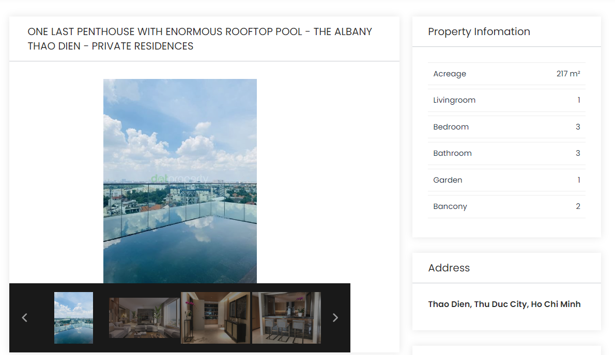

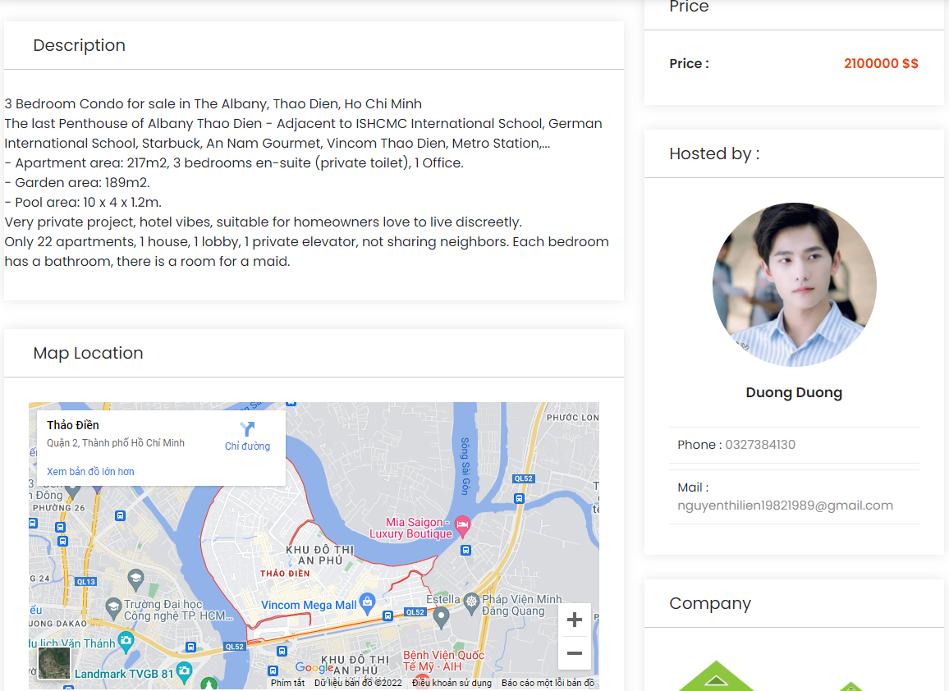

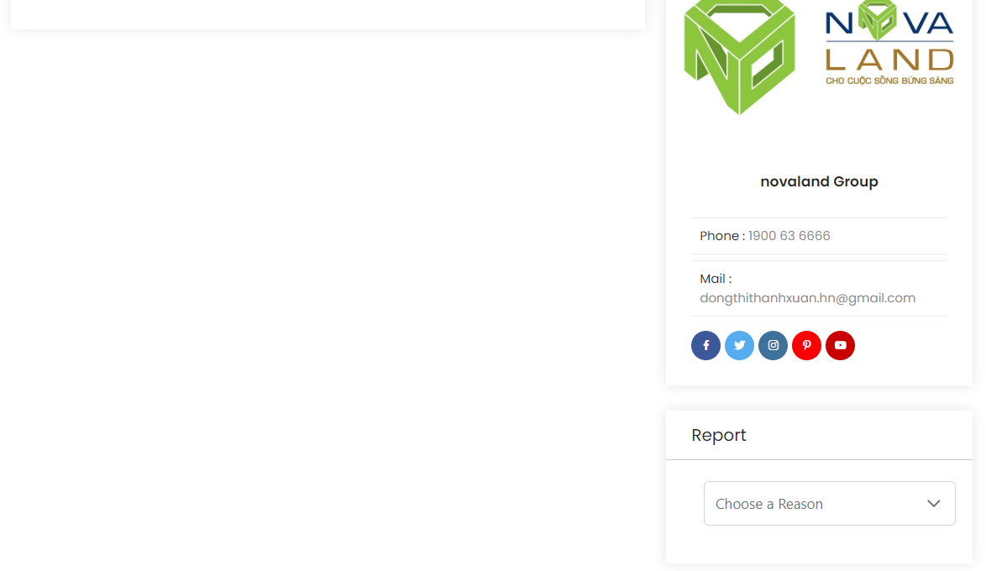

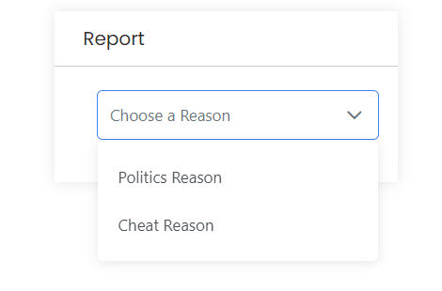

## CONTACT

#### Description

Contact page helps keep in touch between customers and the company. This site will show the address of FindHouse which is as follows and the mail address which when clicked will invoke the local mail client from where they can send an email about feedback or question. Address of the company would be displayed using GoogleMaps.

#### Design and operation

Click on “contact” on header menu and direct user to contact page, users can access this page whether or not they have logged in, so everyone possible to send feedback.

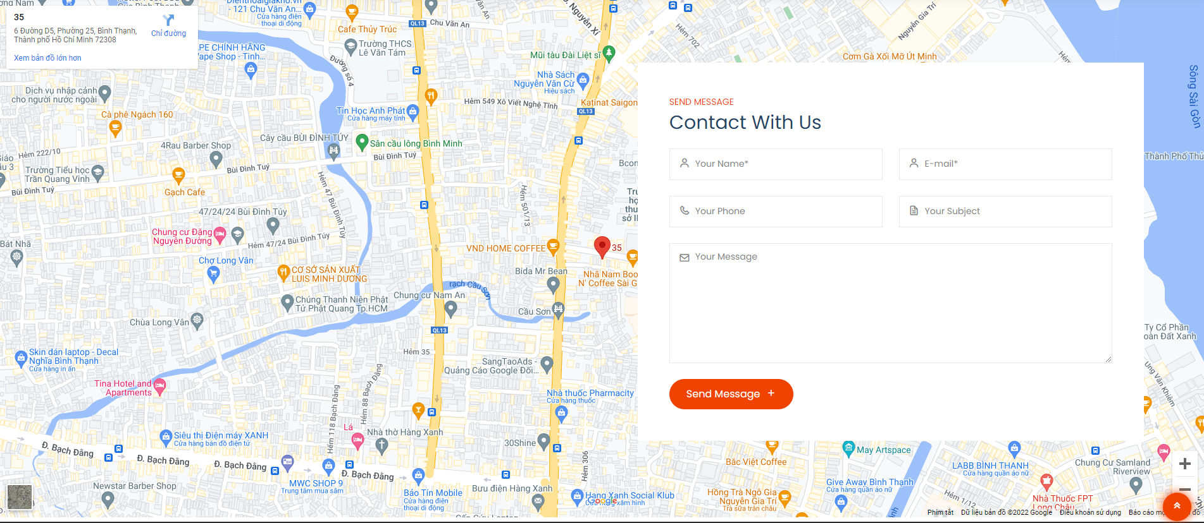

In order to send message, user also need to fill out the form with the following information:

|  |  |
| --- | --- |
| Name | * This field is mandatory. * Must be fill out. |
| E-mail | * This field is mandatory. * Must be valid e-mail address. |
| Phone | * This field is mandatory. * Must be fill out. |
| Subject | * This field is mandatory. * Must be fill out. |
| Message | * This field is mandatory. * Must be fill out. |

## LIVE CHAT

#### Description

Live chat allows users to chat directly with the super admin. Make the exchange of information faster and more efficient.

#### Design and operation

Using the SignalR library allows two-way communication between the user and the server. User will chat directly with superadmin. When sending a message on the superadmin page, a popup message will appear.

Click here



After logging into the user account, just click on the message to start chatting online with the super admin.

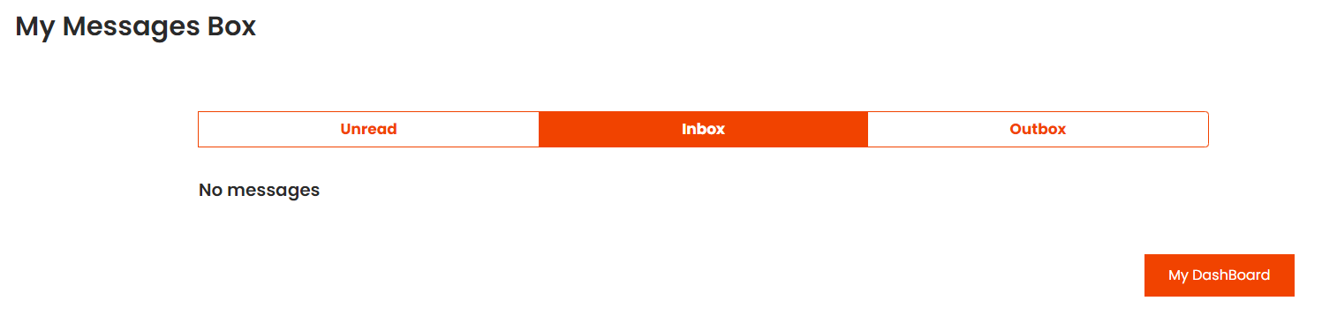

Click here

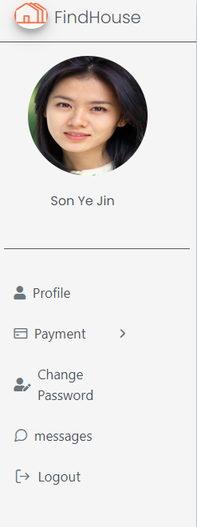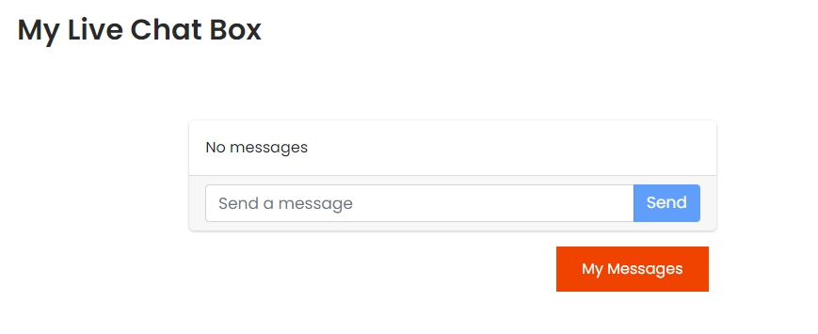

Click here

Click on the message on the navigation bar and the user will see the chat box appear. User can start sending message to super admin.

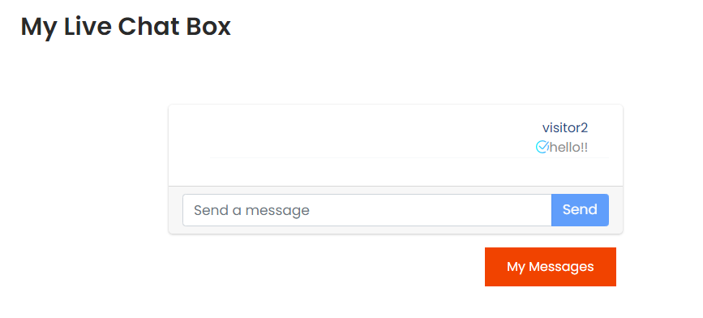

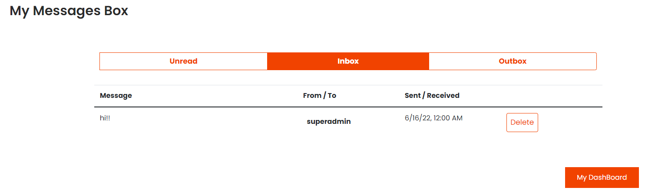

When receiving a reply from the super admin, the user can go to the inbox to check the message.

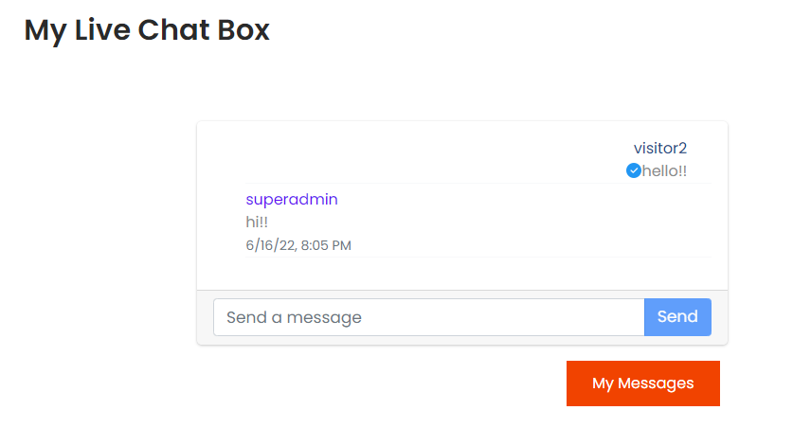



# colored rectangleCHAPTER 5: SUPERADMIN GUIDE

## ACCESS TO ADMIN SITE

#### Description

Granting super admin privileges allows them to edit all the category, news management, and add accounts with all roles. An admin can grant and revoke privileges for any user.

#### Design and operation

Only a user with the role of super administrator and who has already logged in can get to the super administration site.

This is the super administrator’s site:

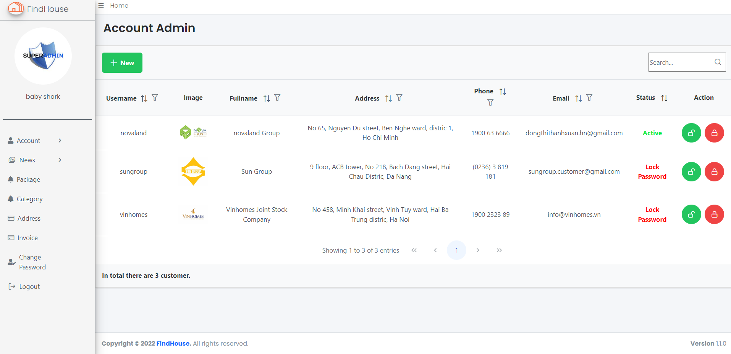

## ACCOUNT MANAGEMENT

#### Description

The super administrator has management rights to manage locks or unlocking all accounts admin, agent, private sale, and visitor.

#### Design and operation

Super Admin can view and manage the list of all users on the website, have the right to activate or deactivate all types of accounts, create a new account except adding new agent (will be done by admin managing that agent).

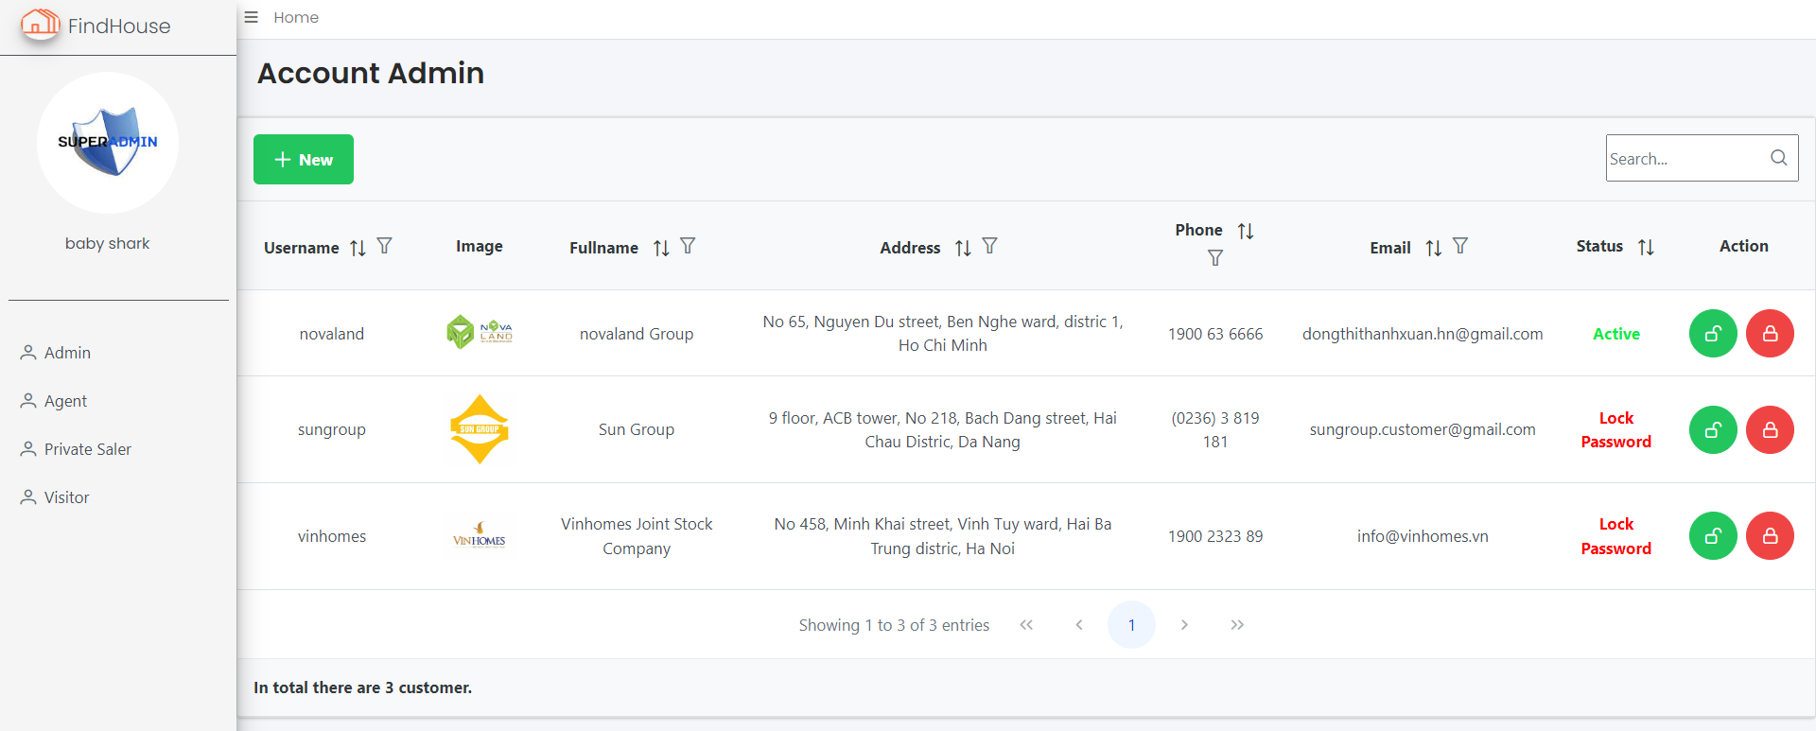

There is also a search and filter tool in the account list to make it easier to find accounts.

**Account status**:

* No.0: newly created, not activated yet.
* No.1: account active.
* No.2: account locked due to incorrect login many times.
* No.3: locked/deleted by admin. (for agent account)
* No.4: account locked by superadmin. Only Super admin can unlock it.

Add new account:

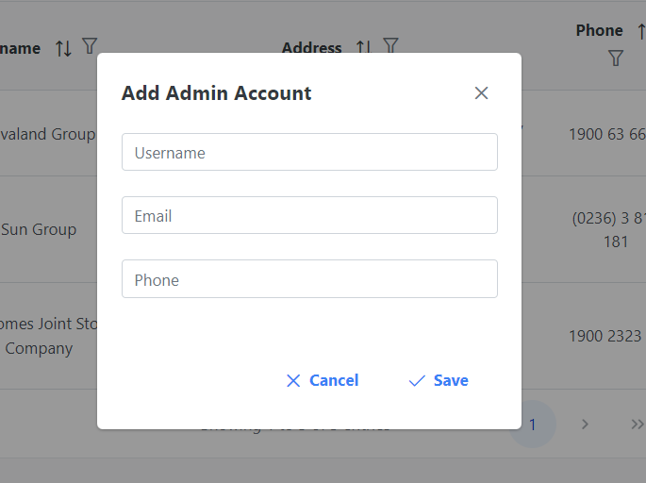

|  |  |
| --- | --- |
| Username | * This field is mandatory. * Username must include: not pass 25 characters alphabet, do not allow blank space, special character and unicode. * Username must be unique in the system. |
| E-mail | * This field is mandatory. * Must be an correctly e-mail address. * E-mail must be unique in the system. |
| Phone | * This field is mandatory. * Must be an correctly phone number: not allow alphabet and special character. |

## NEWS MANAGEMENT

#### Description

Super admin has the right to see all the current news list available on the system. Super admin has the right to view details and set status for posts. This section also displays the list of news reported by viewers.

#### Design and operation

* **List news**

This is the super admin page's news list interface, this page also has a search and filter tool to make it easier to find information.

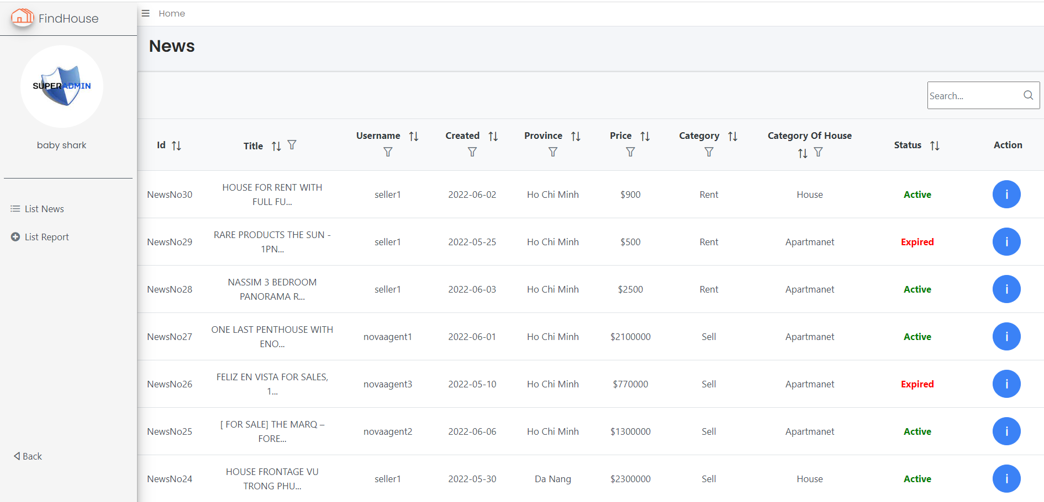

News status:

* No.0: the post of the newly created agent, wait for the admin of that agent to approve.
* No.1: active post (private sale that creates a post will set the status to 1).
* No.2: post locked by admin (for agent account).
* No.3: post locked by super admin.
* No.4: expired post.
* No.5: disable, hidden by admin.

Super admin has the right to block a post if it finds that it violates the rules. When the super admin locks the post, it will note the remark and send it to the seller and also send an email to notify the poster and report information to seller.

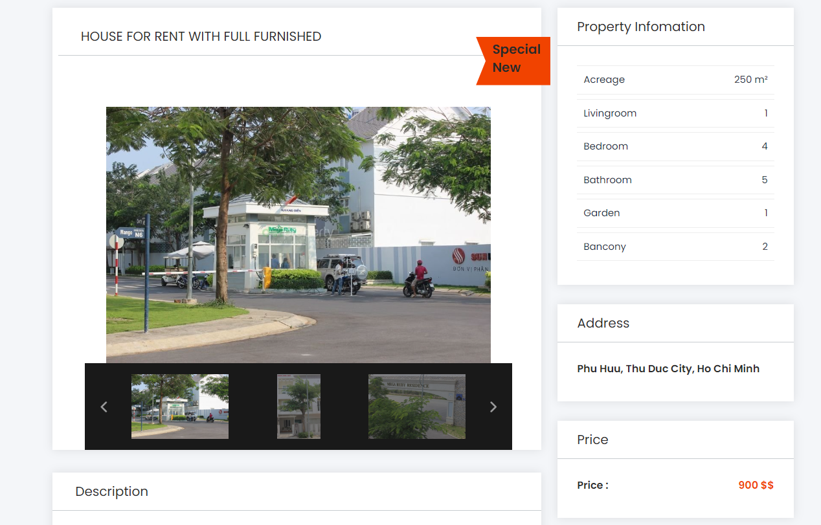

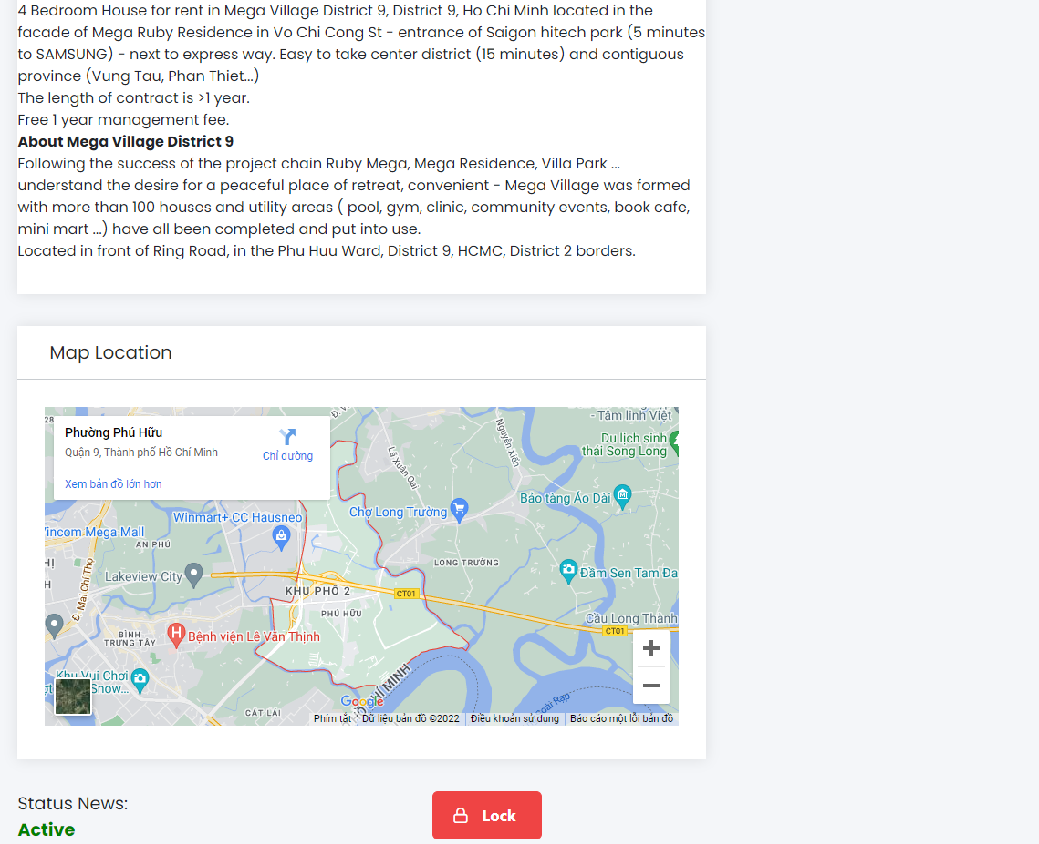

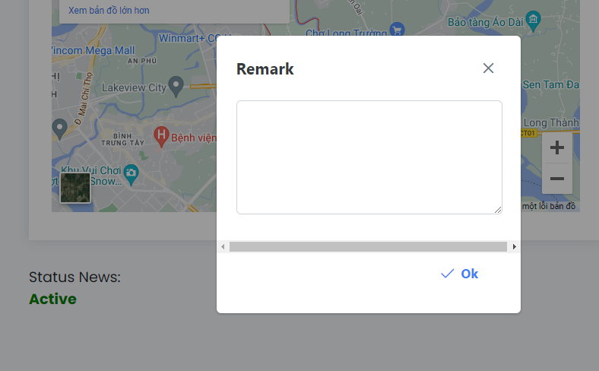

* **List report**

When the post is reported for political reasons:

* Less than 10 reports: a warning will be sent to the poster
* 10 times to report: the notification will be sent to the super admin to check:
* **If the report is correct**: the article will be locked and will send a warning email to the poster and also send an email to the reporter knowing that the article has been locked.
* **If the report is wrong**: an email will be sent to the poster and the post will still be displayed normally.

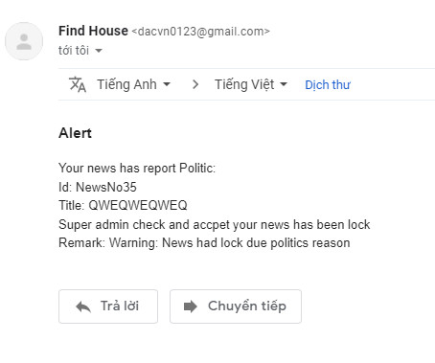 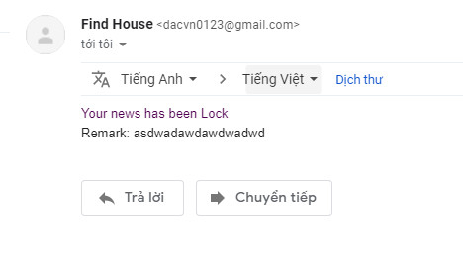

For news reported as cheating, it will be handled automatically:

* Less than 10 reports: news is still active.
* 10 times to report: the message will be automatically locked

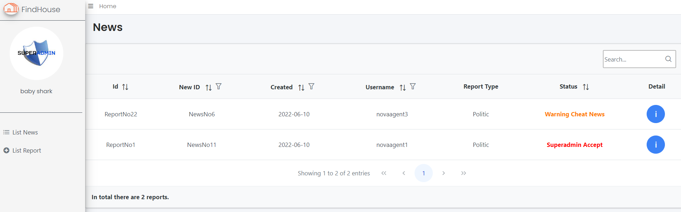

**Report status**:

* No.0: newly created report, " waiting check"
* No.1: report is correct, super admin handled it. "checked-true"
* No.2: report is false, superadmin processed, "check-false"
* No.3: report scam, warned, "send warning mail"
* No.4: report is processed automatically, reported news is automatically changed to locked by superadmin.
* No.5: superadmin/admin send message/remark about news to private seller or agent
* No.6: private seller or agent checked
* Check report politic

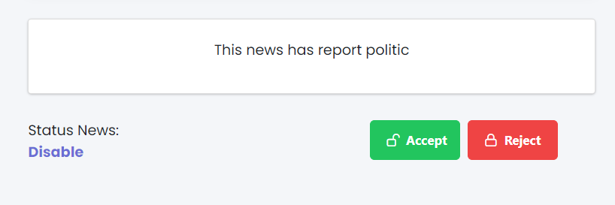

## PACKAGE MANAGEMENT

#### Description

This is the management section about advertising packages for website postings.

#### Design and operation

Super admin can view the list of existing ad packages and create new ad packs for the posting.

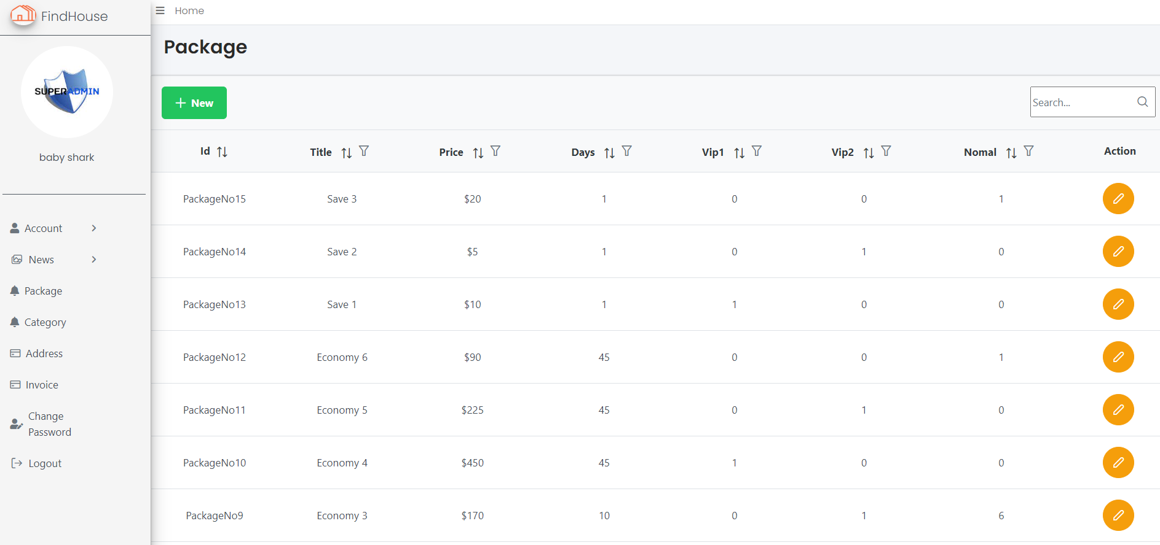

To create a new packet, fill in the following information:

|  |  |
| --- | --- |
| Title | * This field is mandatory. |
| Price | * This field is mandatory. * Must be greater than 0. |
| Number of day | * This field is mandatory. * Minimum 1 day. |
| Type of news | * This field is mandatory. * At least 1 type of news must be selected |
| Content | * This field is mandatory. |

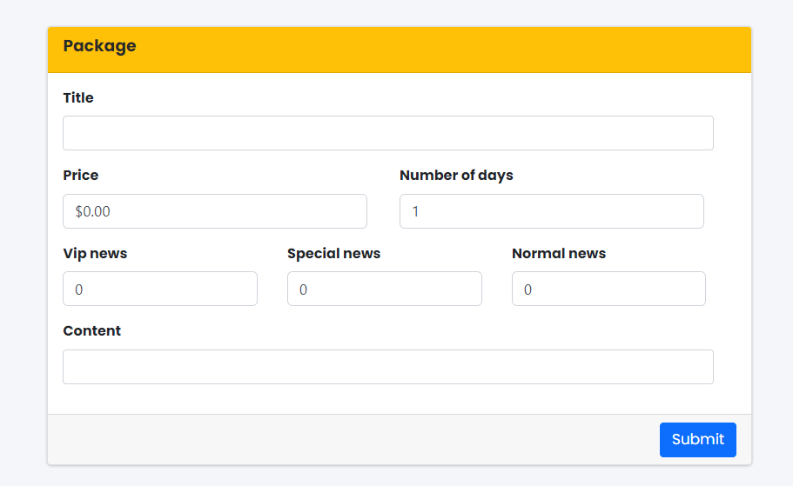

The package information can also be updated except for the date number of the package and the number of news types.

## CATEGORY

#### Description

This is the section that manages the categories of real estate on the website

#### Design and operation

Super admin can add new, edit existing categories or perform deletion for those that are no longer in use.

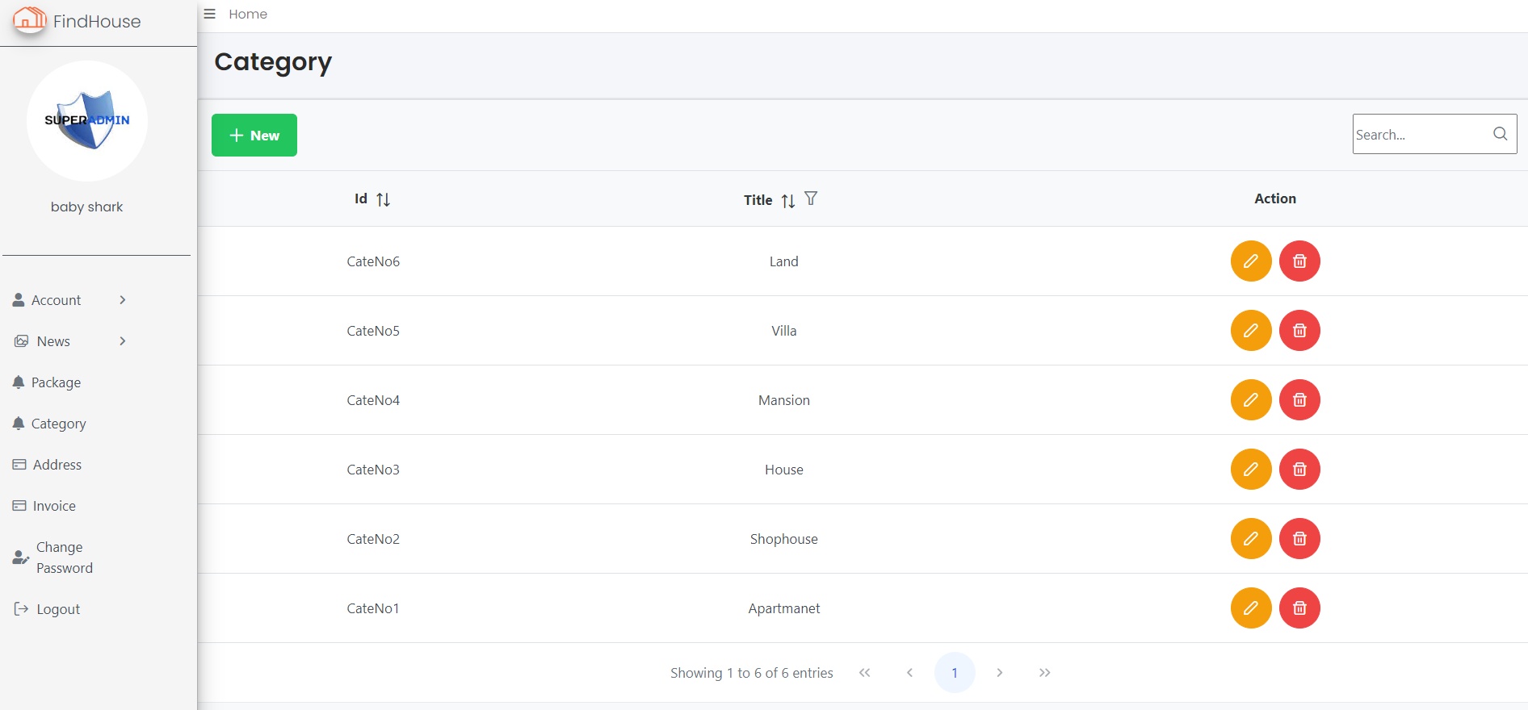

To add a new category just enter the category name and press the ok button.

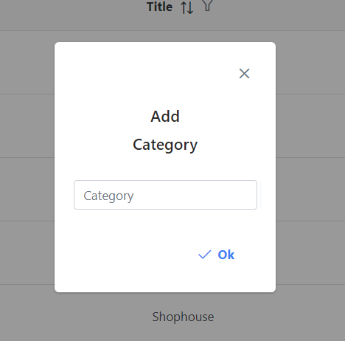

## ADDRESS

#### Description

This section helps the super admin manage information about location and area.

#### Design and operation

Super admin can add new or edit existing loacation. Location information can only be deleted when the province has not yet added city and ward information.

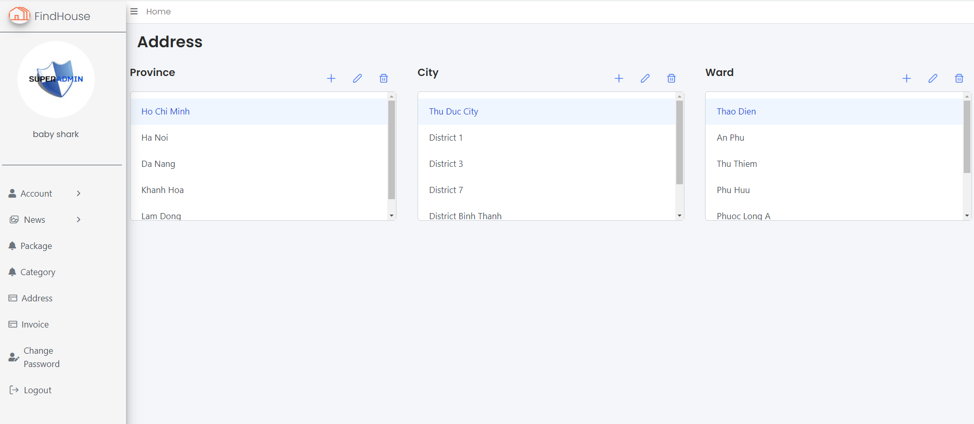

## INVOICE

#### Description

This section will display all information about existing invoices on the system so that the super admin can track and perform statistics.

#### Design and operation

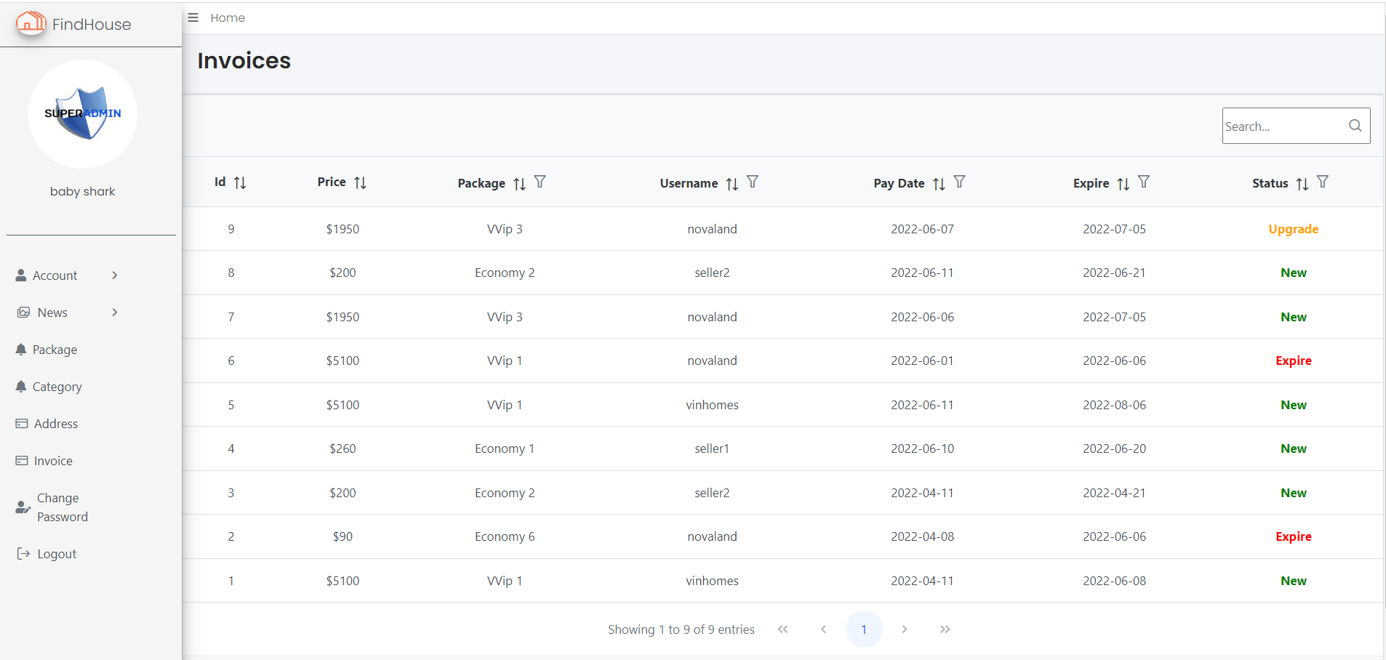

## CHANGE PASSWORD

#### Description

Similar to the visitor, the super admin can also change the password if they need it.

#### Design and operation

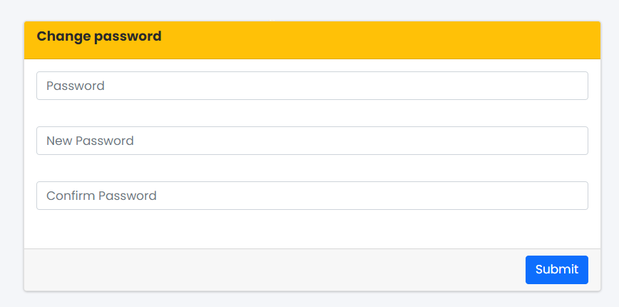

|  |  |
| --- | --- |
| Password | * This field is mandatory. * Password must match current password. |
| New password | * This field is mandatory. * Password must include: at least 6-10 characters, must have at least one special character, a number, one uppercase and one lowercase. |
| Confirm password | * This field is mandatory. * This field must be matched with the “Password” field. |

## LIVE CHAT

#### Description

Live chat help super admin receive and fast reply to users. Super admin will be notified pop-up when a message arrives in the mailbox.

#### Design and operation

Using the SignalR library allows two-way communication between the user and the server. Superadmin will chat directly with user. When sending a message on the superadmin page, a popup message will appear.

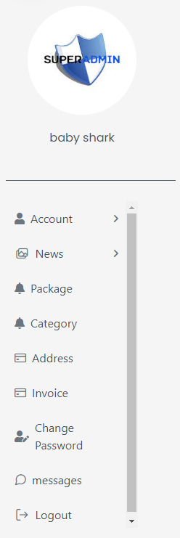

Click here

when super admin clicks on the message it will go to super admin's mailbox. In the mailbox, super admin can see the new messages sent to. Unread messages will be displayed in the unread section.

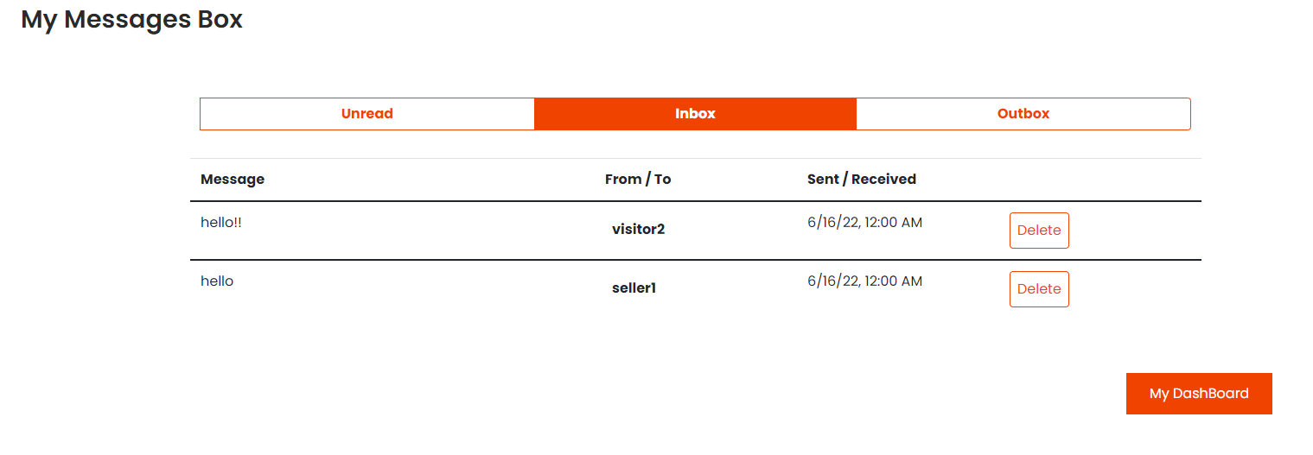

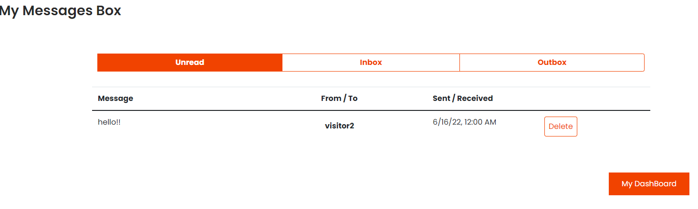

Click on the message that super admin can reply message to the user.

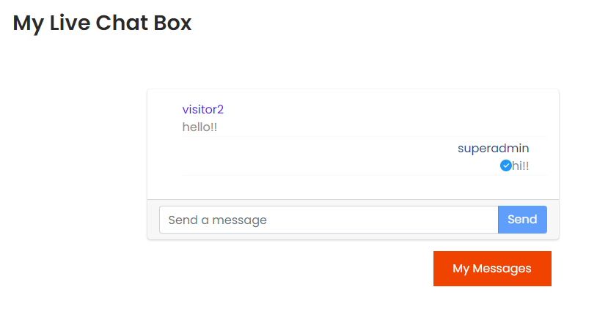



# CHAPTER 6: PRIVATESALE GUIDE

## ACCESS TO PRIVATESALE SITE

#### Description

Granting private sale privileges allows them to manage the news, buy more ad packages to post news, and edit account info.

#### Design and operation

Only a user with the role of private sale and has already logged in can get to the private sale site. After login in as a private sale account, the header menu will display an avatar icon. Click on the icon will direct the user to the private sale site.

Click here



## ACCOUNT INFO

#### Description

Users can view their personal information and edit their information.

#### Design and operation

User can update information such as fullname, e-mail, phone, address and avatar.

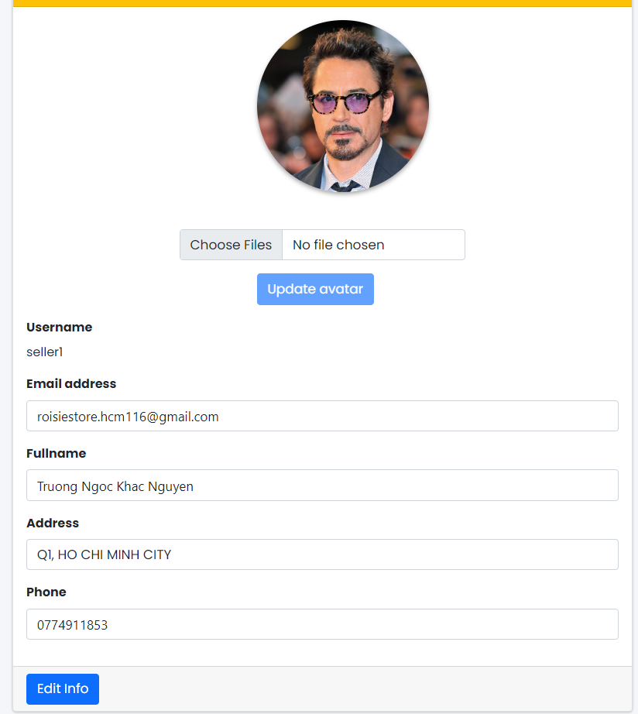

|  |  |
| --- | --- |
| Fullname | * This field is mandatory. * Not allow number and special character. |
| Address | * This field is not mandatory. |
| E-mail | * This field is mandatory. * Must be an correctly e-mail address. * Email must be unique in the system. |
| Phone number | * This field is mandatory. * Must be an correctly phone number: not allow alphabet and special character. |

## NEWS MANAGEMENT

#### Description

News management that displays a list of news and its status, allowing users to add, edit, and add ads to the news.

#### Design and operation

The news management section allows you to edit the content and images of the post as well as set ads.

The ad set for the post is based on the advertising package that the account has registered.

If the ad package still has the package for posting, it will still be set, as usual, if the number of posts has been used up, you can turn off the ads of other posts and set ads for new ones.

Users can choose to turn on/off ads or set another type of post for the post as long as the number of posts is still within the limit of the package.

List news:

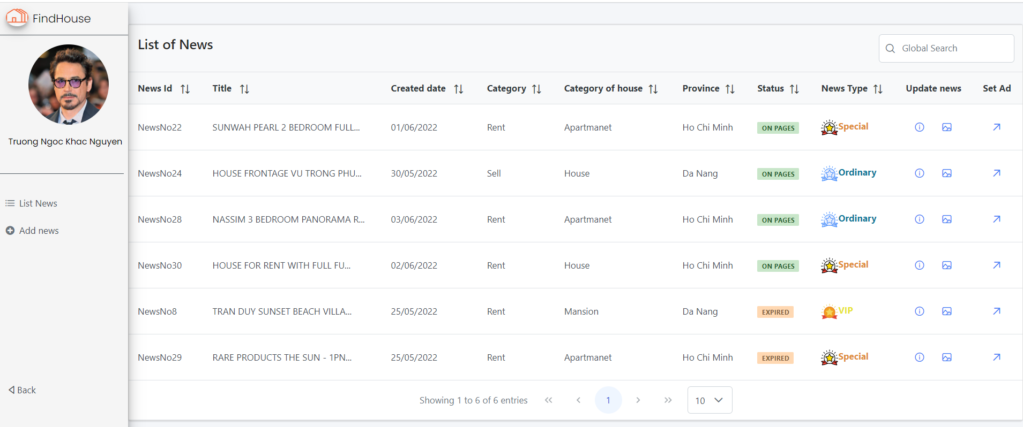

Set ad for post:

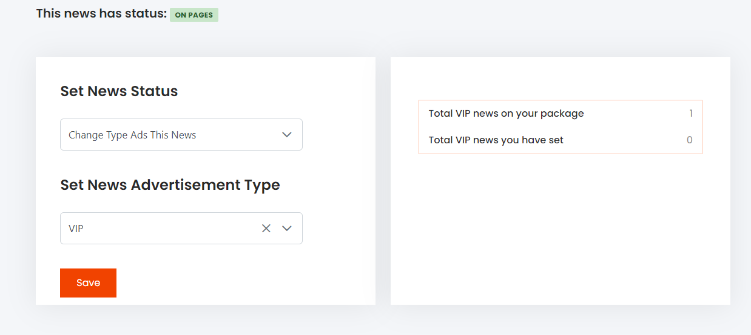

**Add new post**:

To post a new message, users need to fill in the required information and choose an image for the post.

After adding the complete information, the user will review the news again before adding it to the database.

The ad set for the news will be done after successfully adding the news.

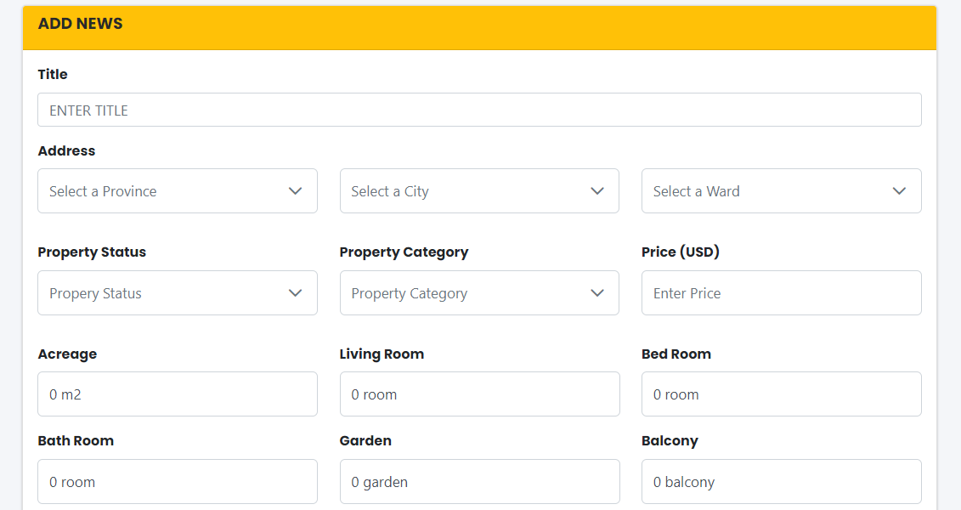

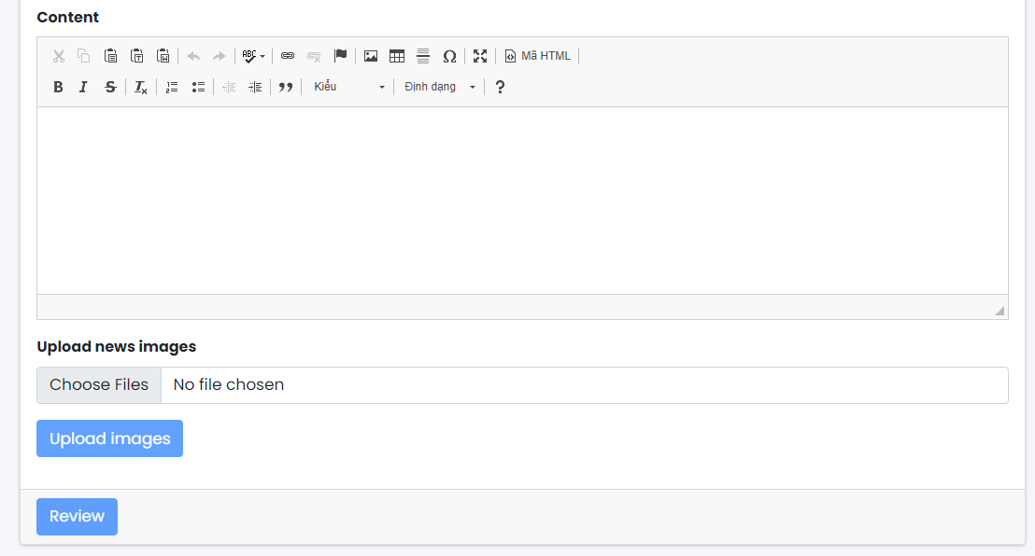

|  |  |
| --- | --- |
| Title | * This field is mandatory. * Ttile not contain forbidden word list. |
| Address | * This field is mandatory. * Must have correct address information. |
| Property status  Property category | * This field is mandatory. * Must select one option in list. |
| Price | * This field is mandatory * Minimum price $0 |
| Acreage  Living room  Bed room  Bath room  Balcony | * This field is mandatory * Minimum number 0 |
| Content | * This field is mandatory. * At least 50 word. * Content not contain forbidden word list. |

## PAYMENT

#### Description

The payment section will manage the purchase and upgrade of the package as well as manage all invoices. This section helps users to know the payment information and the payment will be made through paypal.

#### Design and operation

he user can make an ad pack purchase when the ad pack expires or can upgrade the package to a package with a higher price and advertising days equal to the old one and will pay the difference between the 2 packages.

If the package cannot be upgraded, you must use it until the expiration date and buy a new package.

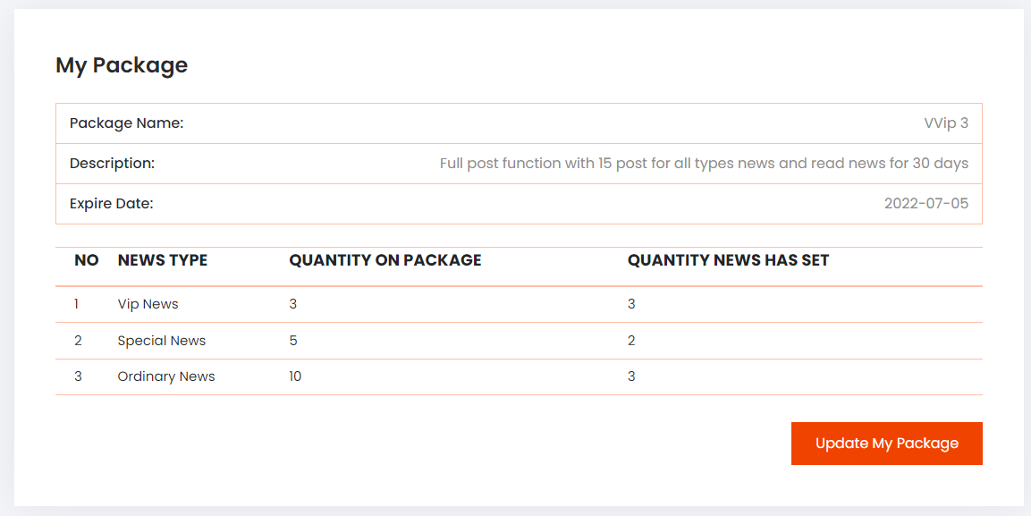

In the payment history section, users can review the information of the packages they have purchased and the packages which is using.

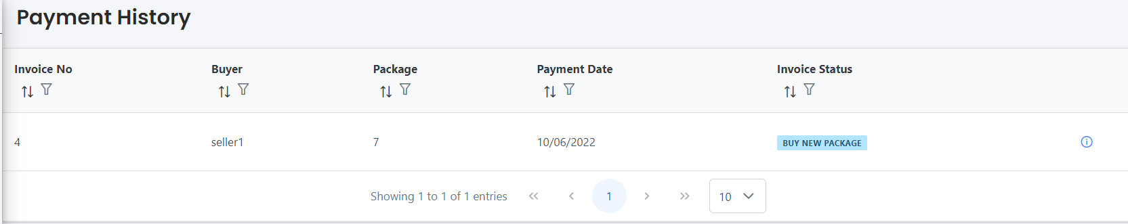

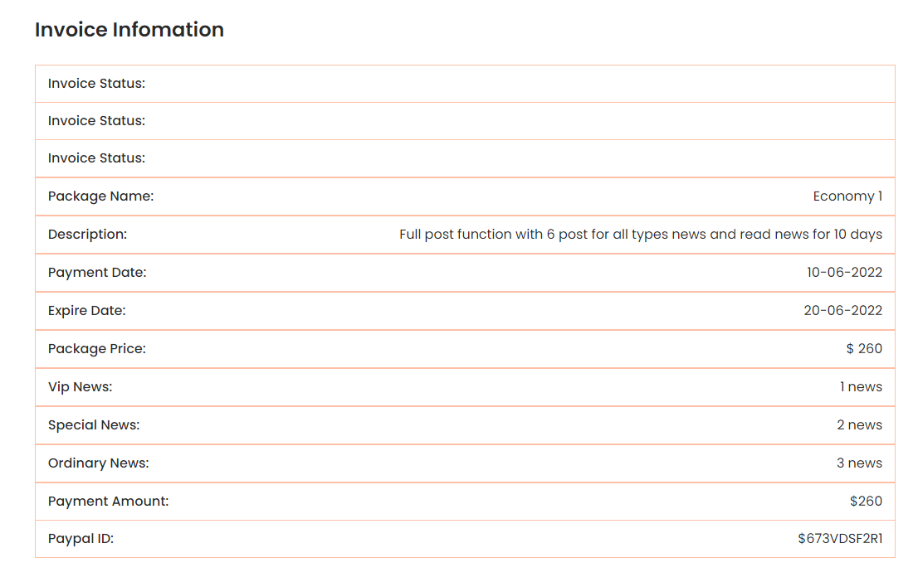

## NOTIFICATION

#### Description

This page will display all the information related to the reported posts.

#### Design and operation

For private sellers, they will receive a notification that their post has been reported and the current status of the post so they can edit the post or contact the admin to resolve it.

When the super admin sends a mail and remark to the private seller, the private seller will check if they have received the information and the news status will change to checked so that the super admin knows that the information has been received.

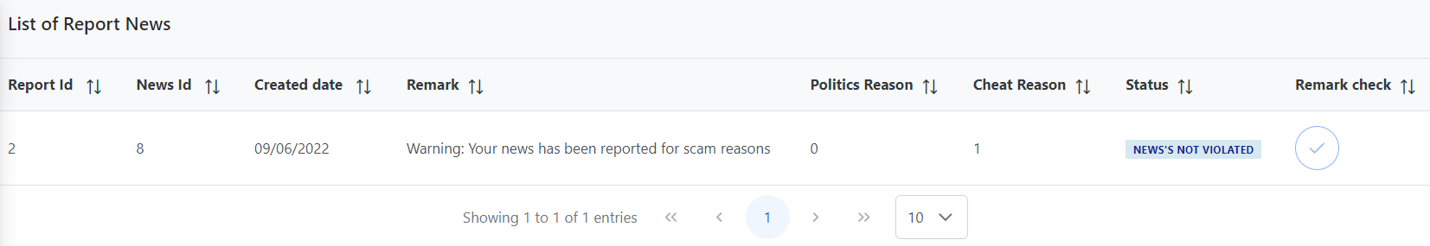

**Report status**:

* No.0: newly created report, " waiting check"
* No.1: report is correct, super admin handled it. "checked-true"
* No.2: report is false, superadmin processed, "check-false"
* No.3: report scam, warned, "send warning mail"
* No.4: report is processed automatically, reported news is automatically changed to locked by superadmin (newsstt=3)
* No.5: superadmin/admin send message/remark about news to private seller or agent
* No.6: private seller or agent checked

## CHANGE PASSWORD

Reference to section 8 chapter 5.

## LIVE CHAT

Reference to section 8 chapter 4.



# CHAPTER 7: ADMINISTRATOR GUIDE

## ACCESS TO ADMINISTRATOR SITE

To access the admin page, the account must have the role of admin.

Reference to section 1 chapter 6.

## ACCOUNT INFO

Reference to section 2 chapter 6.

## NEWS MANAGEMENT

#### Description

Admin can review the list and details of all news of the agents that admin is managing.

#### Design and operation

Admin will have the right to manage the news such as locking if the news is infringing or setting ads for the posts that the agent creates. If the post has been locked by the super admin, the admin can’t set the status for the post.

When the agent creates a new message, the information will be sent to the admin to wait for approval:

* Accept: admin will set the agent's information
* Reject: the post will be locked and no action will be taken for this post and the message will be sent to the agent.
* Hidden: the post will be hidden, but you can still change the status to set an ad for this post.

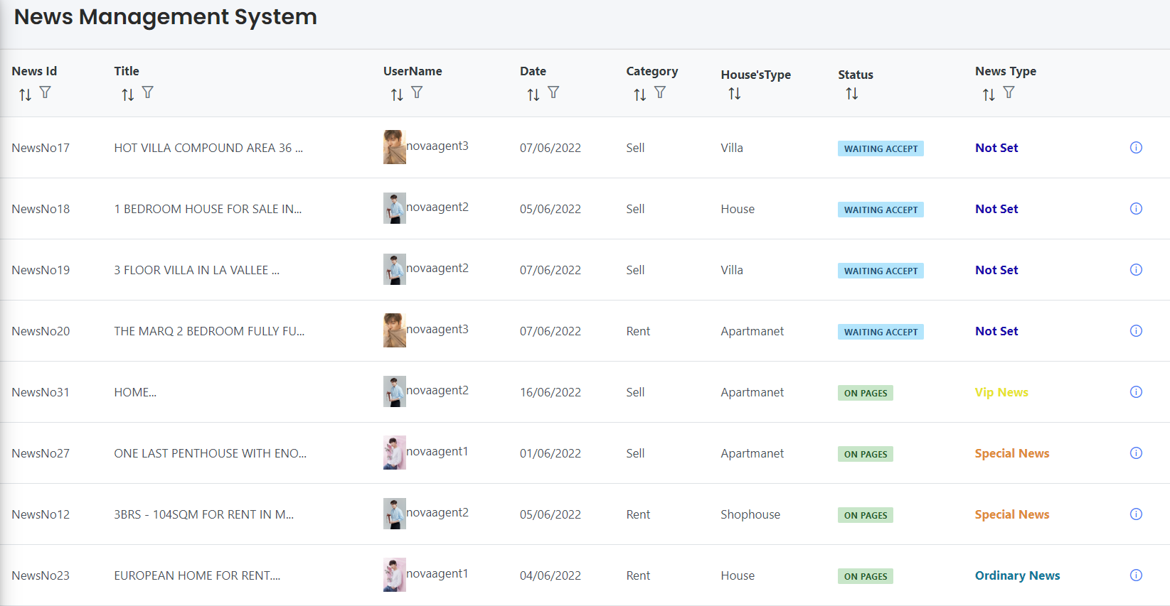

News status:

* No.0: the post of the newly created agent, wait for the admin of that agent to approve.
* No.1: active post (private sale that creates a post will set the status to 1).
* No.2: post locked by admin (for agent account).
* No.3: post locked by super admin.
* No.4: expired post.
* No.5: disable, hidden by admin.

**Set ad for news:** Only the admin has the right to set ads for the agencies that the admin manages, Agents only have the right to create posts, but not to set ads for their news.

The ad set for the post is based on the advertising package that the account has registered.

If the ad package still has the package for posting, it will still be set, as usual, if the number of posts has been used up, you can turn off the ads of other posts and set ads for new ones.

Users can choose to turn on/off ads or set another type of post for the post as long as the number of posts is still within the limit of the package.

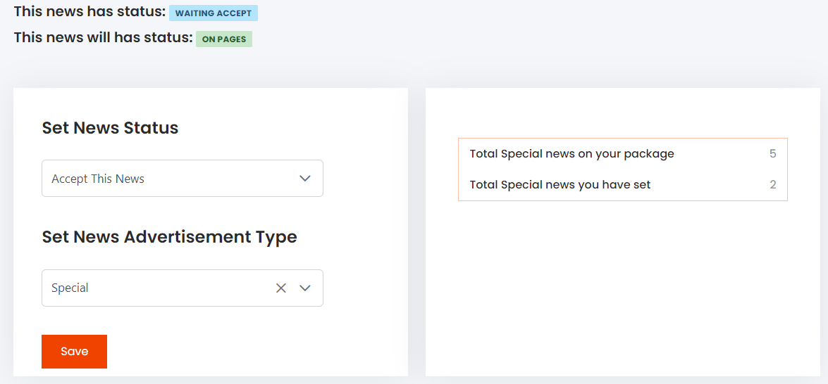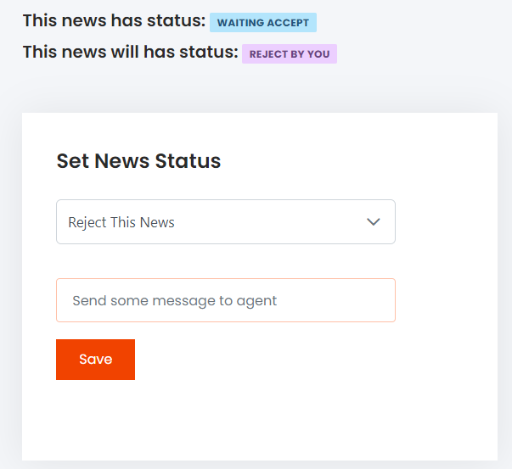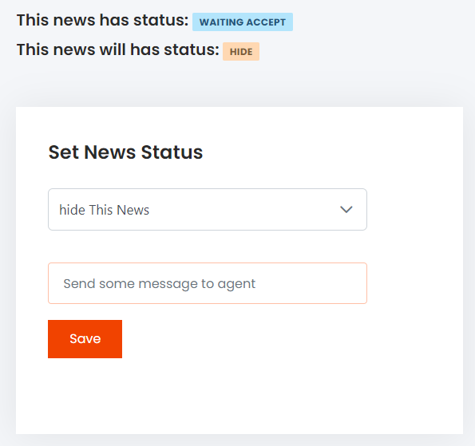

## AGENT MANAGEMENT

#### Description

Admin can review all the agents on the list, serch and filter to find agent.

#### Design and operation

Admin can create a new agent account, and lock/unlock the agent account that the admin manages, if the account is locked by super admin, admin can't change the status for that account.

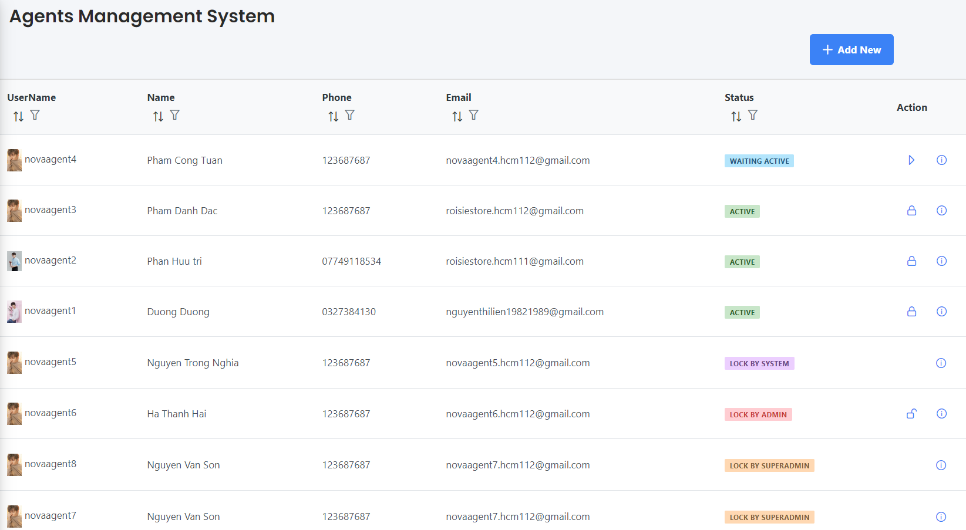

Create new agent account: to create new account, admin must be fill out the following information:

|  |  |
| --- | --- |
| Username | * This field is mandatory. * This field will be used as login credential along with customer’s password. * Username must include: not pass 25 characters alphabet, do not allow blank space, special character and unicode. * Username must be unique in the system. |
| Fullname | * This field is mandatory. * Not allow number and special character. |
| E-mail | * This field is mandatory. * Must be an correctly e-mail address. * Email must be unique in the system. |
| Phone number | * This field is mandatory. * Must be an correctly phone number: not allow alphabet and special character. |

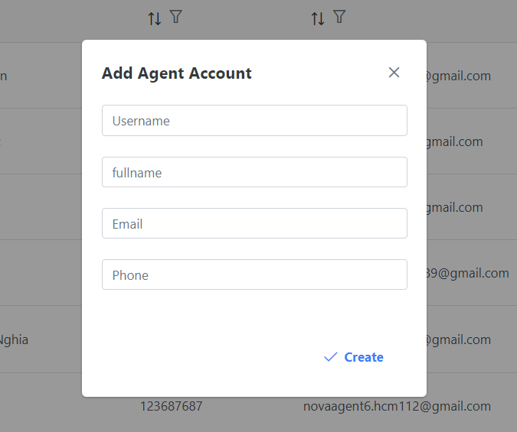

When a new agent account is created, you must wait for the admin to activate it before that account can be logged in.

## PAYMENT

Reference to section 4 chapter 6.

## NOTIFICATION

#### Description

This page will display all the information related to the reported posts of agent that manage by admin.

#### Design and operation

When the agent's news is reported, it will be notified to the admin who manages that agent:

Politics reason:

* Less than 10 reports will show a warning message.
* If 10 reports are enough, the news will be hidden and wait for the super admin to confirm.

Scam reason:

* Less than 10 reports, there’s no message and the status of the news is still the same.
* 10 reports will be reported as scams and the news will be locked

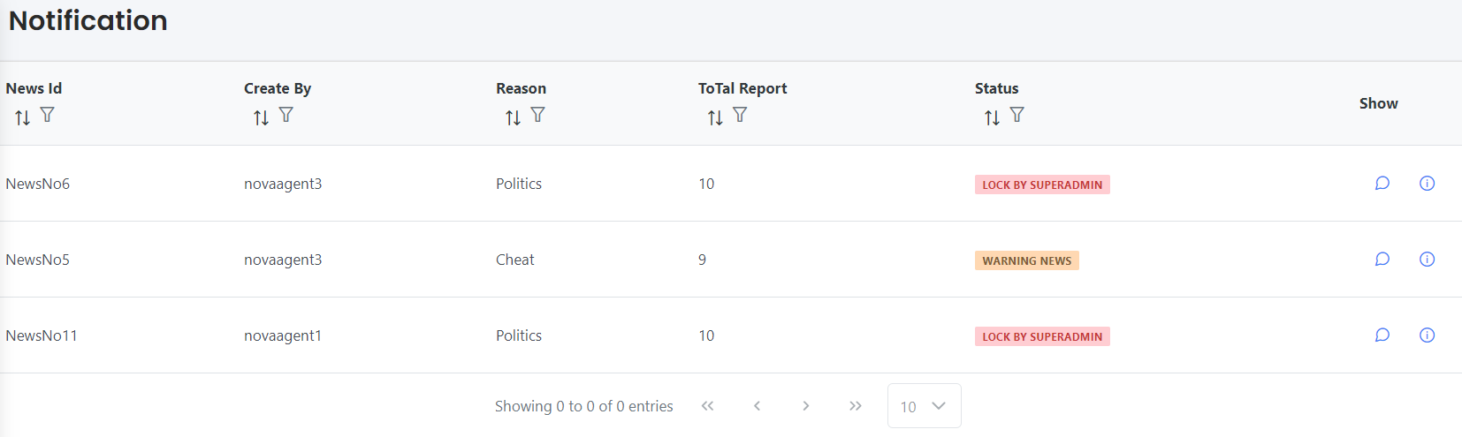

## CHANGE PASSWORD

Reference to section 8 chapter 5.

## LIVE CHAT

Reference to section 8 chapter 4.



# CHAPTER 8: AGENT GUIDE

## ACCESS TO AGENT SITE

To access the agent page, the account must have the role of agent.

Reference to section 1 chapter 6.

## ACCOUNT INFO

Reference to section 2 chapter 6.

## NEWS MANAGEMENT

Reference to section 3 chapter 6.

**Note**: Agents cannot set ads for their own news but have to wait for admin approval.

## NOTIFICATION

Reference to section 5 chapter 6.

## CHANGE PASSWORD

Reference to section 8 chapter 5.

## LIVE CHAT

Reference to section 8 chapter 4.



# CHAPTER 9: DEVELOPER GUIDE

## INSTALL SQL SERVER

* Open and connect to SQL Server.

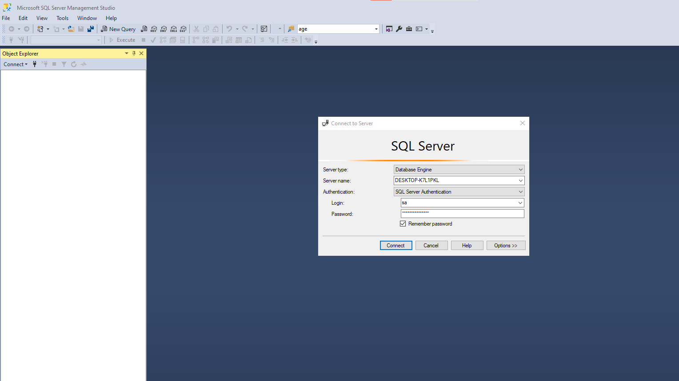

* Select database.sql in folder “Doanky3”

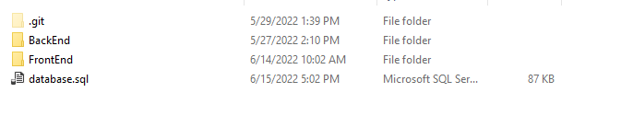

## INSTALL VISUAL STUDIO

* Open project “BackEnd” in folder “Doanky3” with visual studio.
* Open appsetting.json:
  + Change “Serve” to the correct “Serve” on your computer.
  + Change the “username” and “password” with the correct connection information to the sql server on your computer.

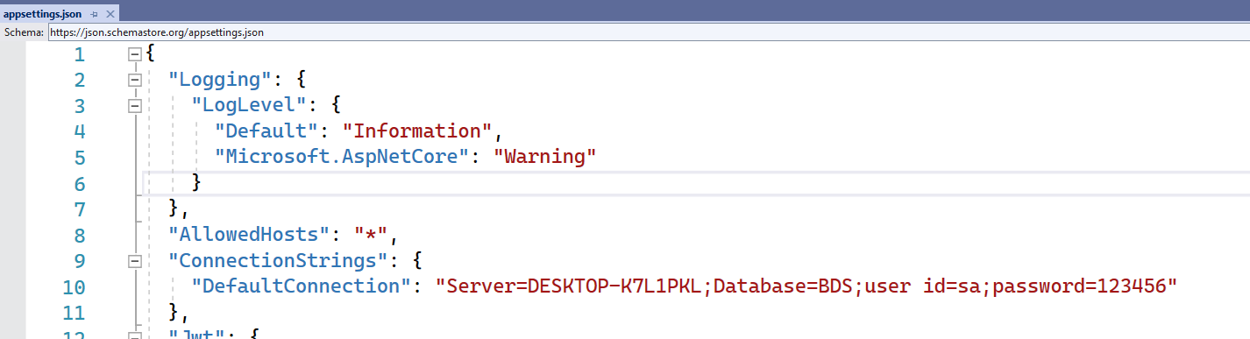

## INSTALL VISUAL STUDIO CODE

* Open project “FrontEnd” in folder “Doanky3” with visual studio code.
* Direct to FindHouse => run ng serve --open

This home page will display with link : http://localhost:4200/

